| **Ex. No : 3**  **Date:** | **Study Basic Commands of Wireshark** |
| --- | --- |

**Aim**

To study about installation and the basic commands of Wireshark.

**About Wireshark**

Wireshark is an open-source network protocol analysis tool developed by Gerald Combs in 1998 to review packet captures of network activity Wireshark is a packet sniffer and analysis tool that captures network traffic on the local network and stores that data for offline analysis. Wireshark captures network traffic from Ethernet, Bluetooth, Wireless (IEEE 802.11), Token Ring, Frame relay connections, and more.

**Installation of Wireshark**

<https://www.wireshark.org/download.html>

When you open you will see list of all network interfaces on your computer. U need to choose which interface u want Wireshark to capture packets on. Select the Wi-Fi option. After this, a new window opens up, which will show the current traffic on the network. Below is the image which tells us about the live capture of packets and our Wireshark will look like:

**Wireshark Interface**

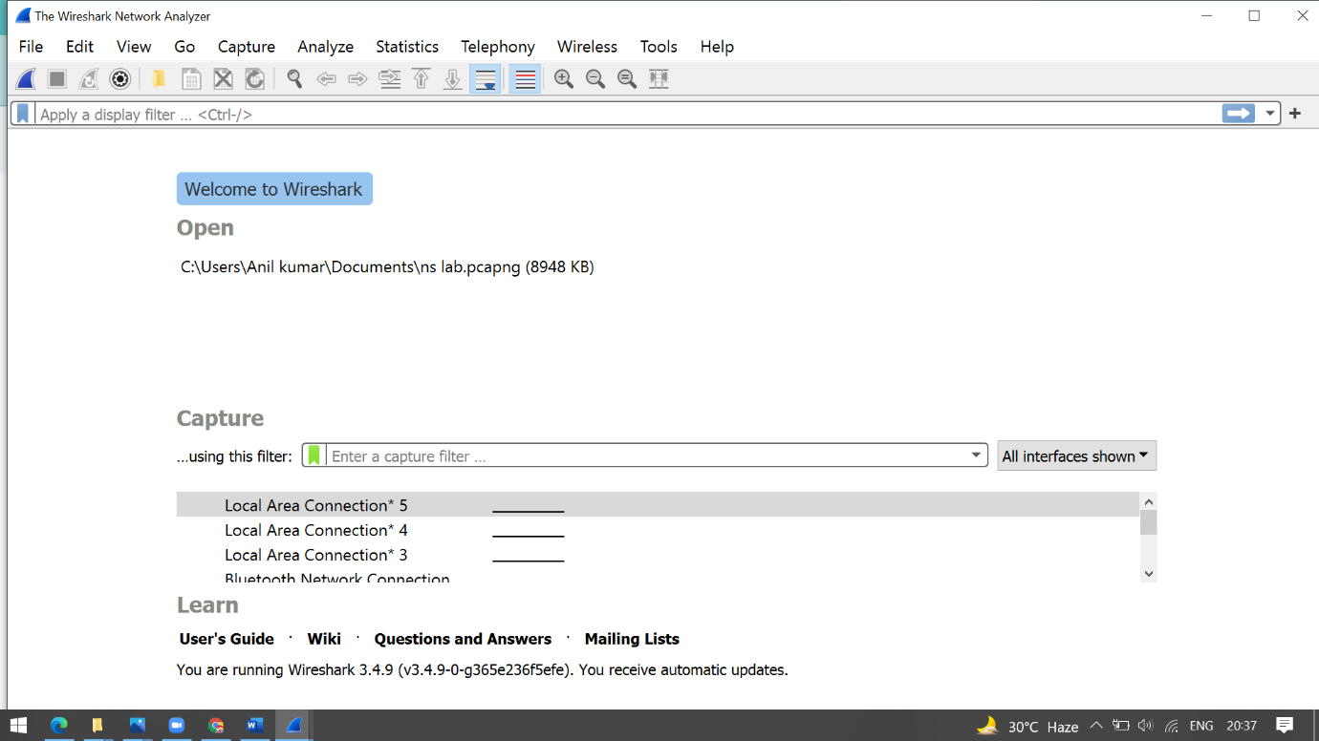

**Screen/Interface of the Wireshark**

The screen/interface of the Wireshark is divided into five parts:

* First part contains a menu bar and the options displayed below it. This part is at the top of the window. File and the capture menus options are commonly used in Wireshark. The capture menu allows to start the capturing process. And the File menu is used to open and save a capture file.
* The second part is the packet listing window. It determines the packet flow or the captured packets in the traffic. It includes the packet number, time, source, destination, protocol, length, and info. We can sort the packet list by clicking on the column name.
* Next comes the packet header- detailed window. It contains detailed information about the components of the packets. The protocol info can also be expanded or minimized according to the information required.
* The bottom window called the packet contents window, which displays the content in ASCII and hexadecimal format.
* At last, is the filter field which is at the top of the display. The captured packets on the screen can be filtered based on any component according to your requirements. For example, if we want to see only the packets with the HTTP protocol, we can apply filters to that option. All the packets with HTTP as the protocol will only be displayed on the screen, shown below:

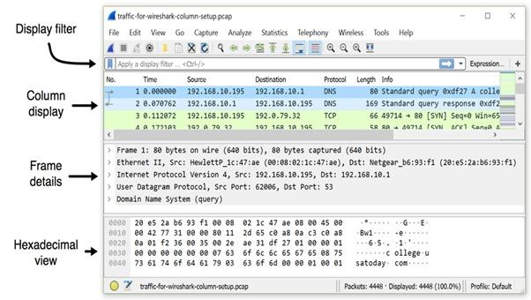

[13:53, 10/19/2021] +91 98408 75382: Figure: Viewing a pcap using Wireshark's default column display.

[13:54, 10/19/2021] +91 98408 75382: Wireshark's default columns are:

• No. -Frame number from the beginning of the pcap. The first frame is always 1.

• Time - Seconds broken down to the nanosecond from the first frame of the pcap. The first frame is always 0.000000.

• Source - Source address, commonly an IPv4, IPv6, or Ethernet address.

• Destination - Destination address, commonly an IPv4, IPv6, or Ethernet address.

• Protocol - Protocol used in the Ethernet frame, IP packet, or TCP segment (ARP, DNS, TCP, HTTP, etc.).

• Length - Length of the frame in bytes

**Boolean Expression in Display Filter**

Wireshark's display filter uses Boolean expressions, so you can specify values and chain them together. The following expressions are commonly used:

Equals: == or cq.

And: &&or and

Or: || (double pipe) or or

Examples of these filter expressions follow:

* ip addr eq 192.168.10.195 and ip.addr == 192.168.10.1
* http.request && ip.addr == 192.168.10.195
* http.request || http response
* Dns qry name contain Microsoft or qry name contains windows

**Arp -a :-**

The Address Resolution Protocol (ARP) maps internet addresses to hardware addresses. TCP/IP uses ARP to collect and distribute the information for mapping

Start a Wireshark capture. Use arp -d to clear the ARP cache. Use ping <default gateway address> to ping the default gateway address. Use arp -a to view the ARP cache and confirm an entry has been added for the default gateway address.

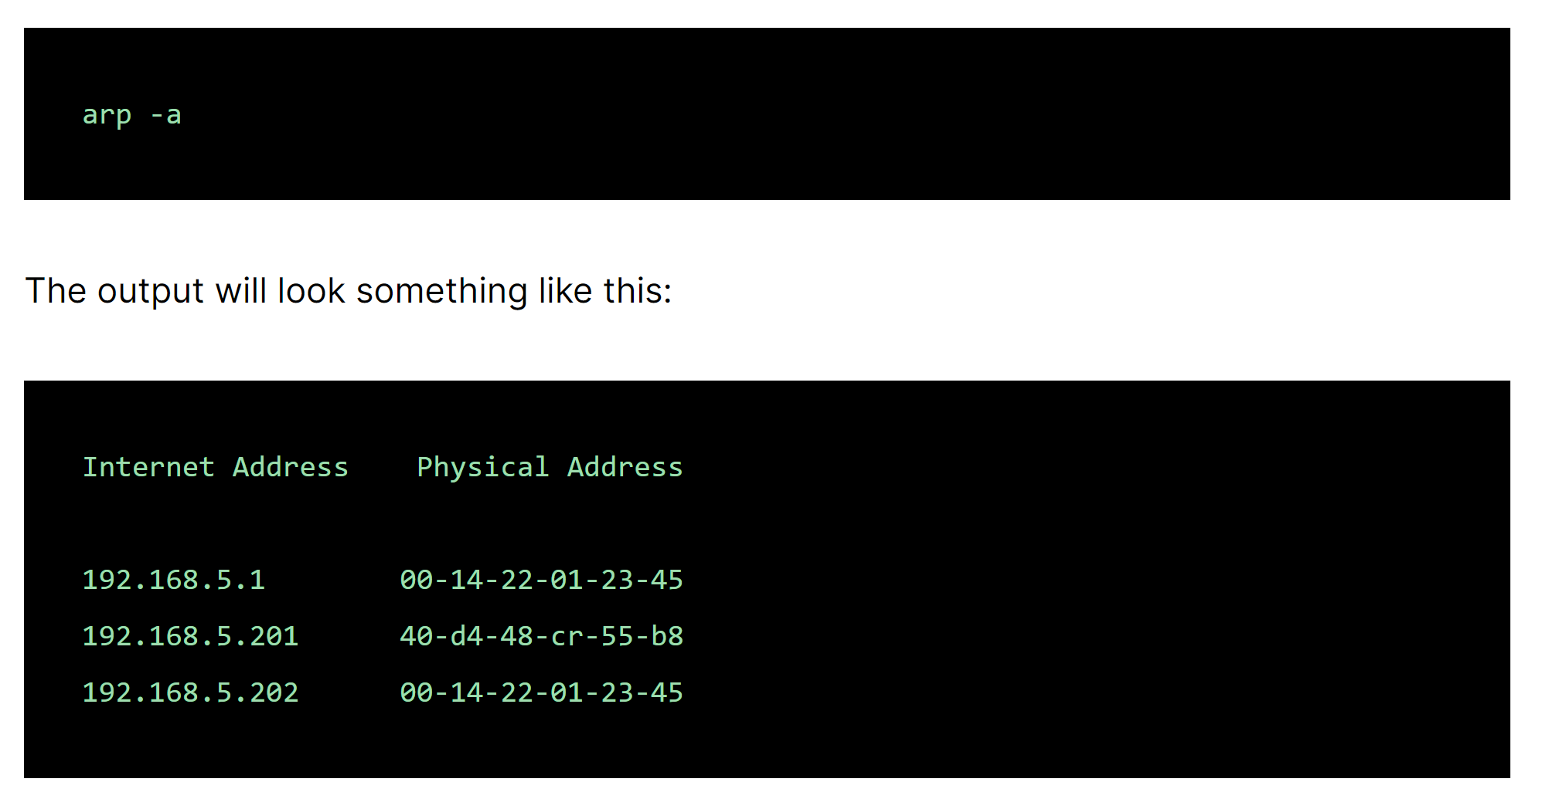

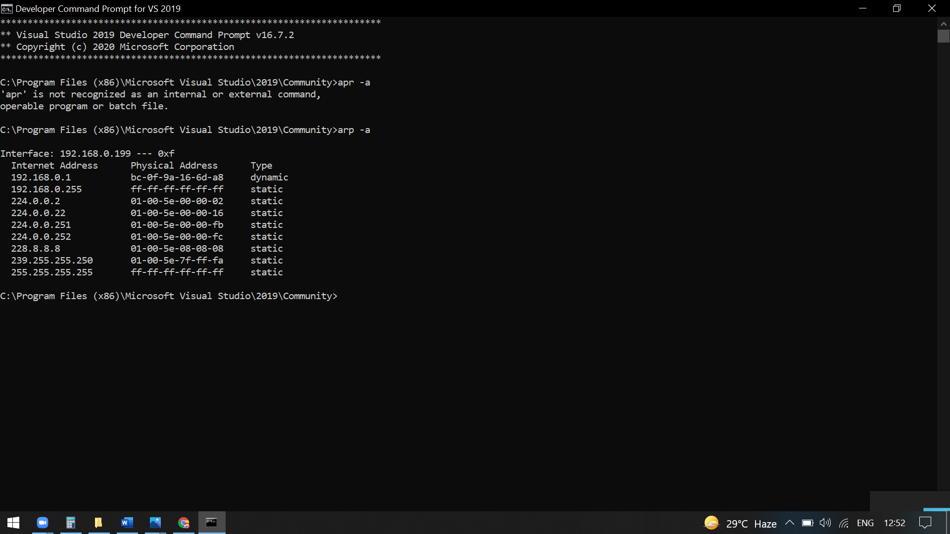

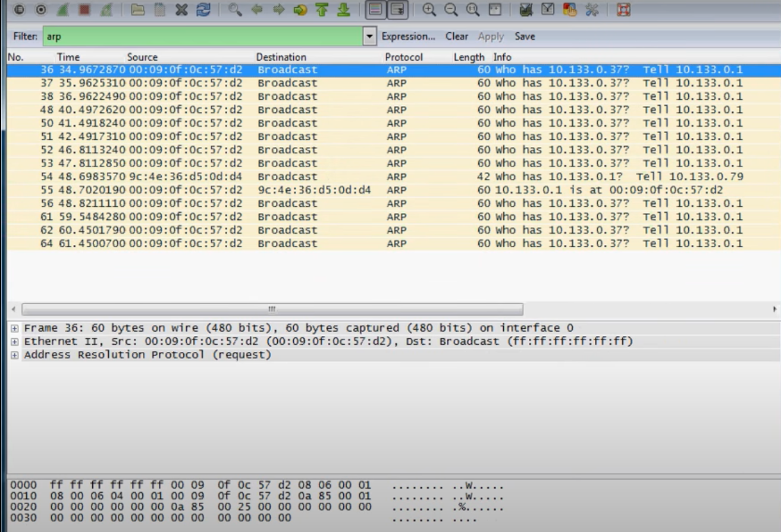

There are several ways to mark and unmark packets. From the Edit menu you can select from the following:

* Mark/Unmark Packet toggles the marked state of a single packet. This option is also available in the packet list context menu.
* Mark All Displayed set the mark state of all displayed packets.
* Unmark All Displayed reset the mark state of all packets.

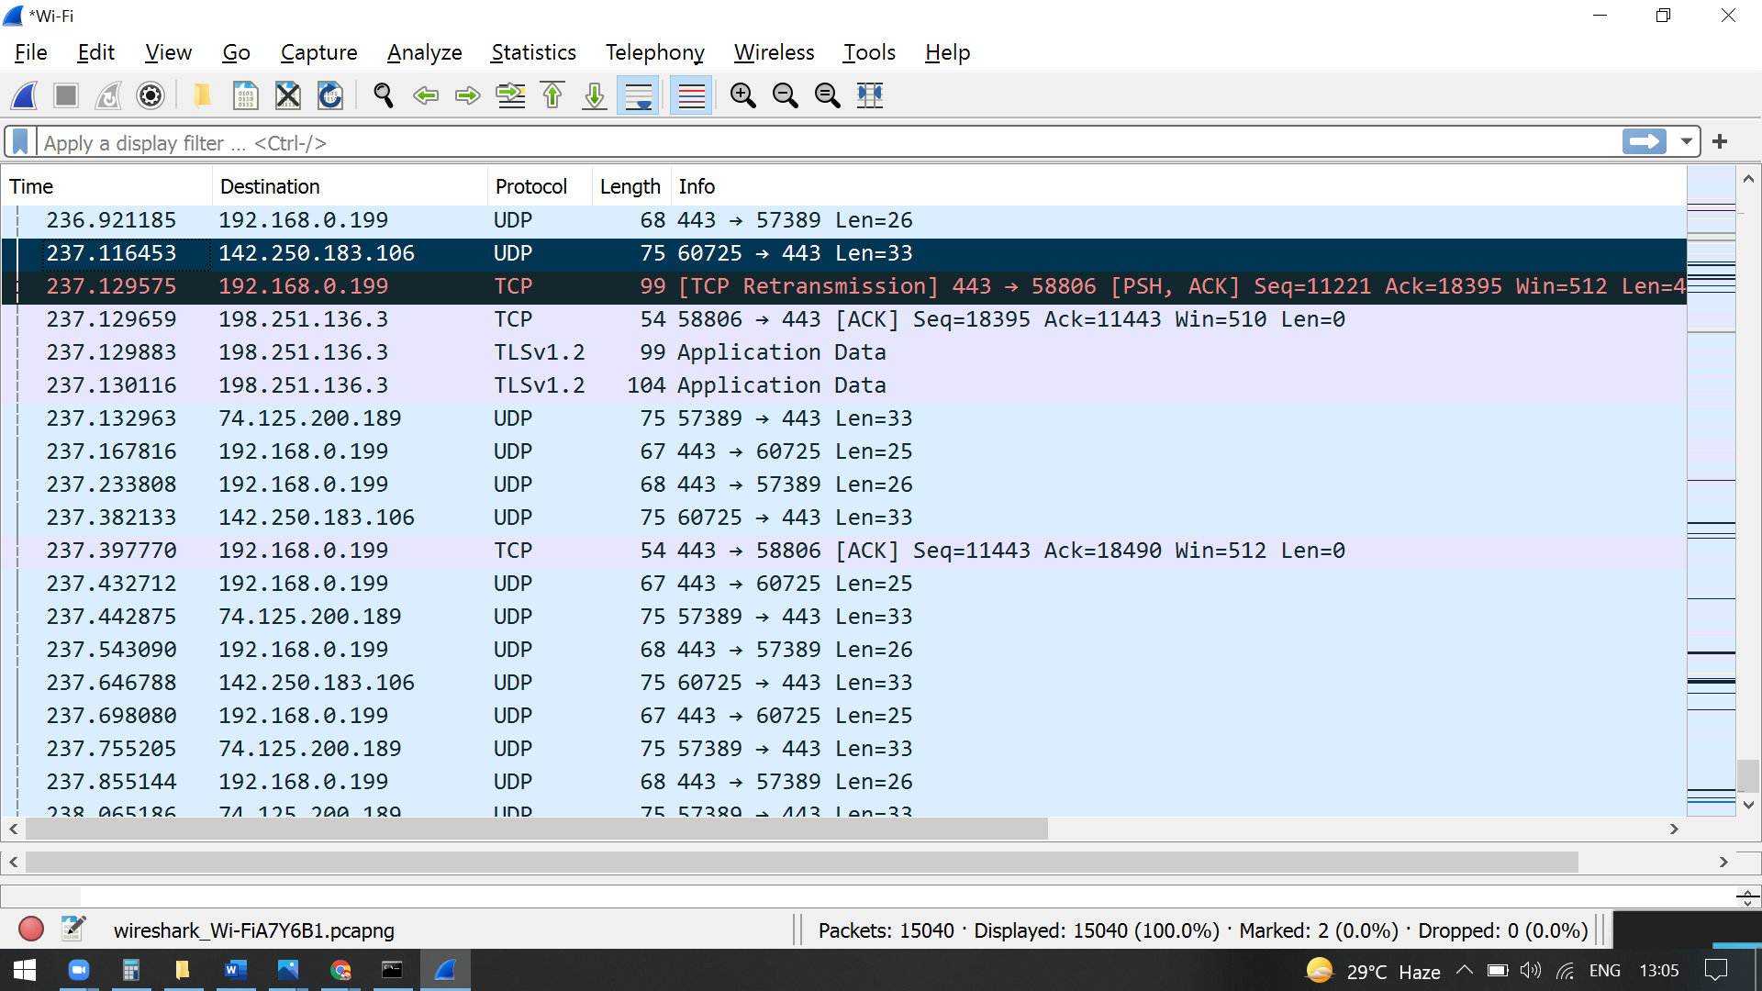

**ARP Spoofing**

* The ARP protocol was not designed for security, so it does not verify that a response to an ARP request really comes from an authorized party.
* It also lets hosts accept ARP responses even if they never sent out a request. This is a weak point in the ARP protocol, which opens the door to ARP [spoofing attacks](https://www.imperva.com/learn/ddos/ip-spoofing/).
* An ARP spoofing, also known as ARP poisoning, is a [Man in the Middle](https://www.imperva.com/learn/application-security/man-in-the-middle-attack-mitm/) (MitM) attack that allows attackers to [intercept](https://www.imperva.com/learn/application-security/man-in-the-middle-attack-mitm/) communication between network devices.

**Detection:**

* Go to Analyze > Expert Information (Last Option as per v3.2.5).
* Sort the Protocol in ascending order, and you will see ARP/RARP if any ARP Attacks.
* You will see Warning as Severity, Duplicate IP Address... as Summary, and so on.

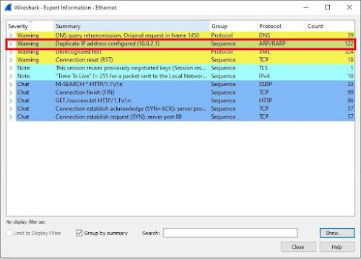

**Delta Times :-**

There is significant TCP Delta Times, and most of the packets are going to 192.168.0.136. In this example, it would be good to identify the remote systems that are serving packets to 192.168.0.136, in an attempt to understand why there is latency in the transmission of data

1. In Wireshark, press Ctrl + Shift + P (or select Edit > Preferences).
2. In the left panel, expand Protocols and select TCP.
3. Ensure Calculate conversation timestamps is checked.

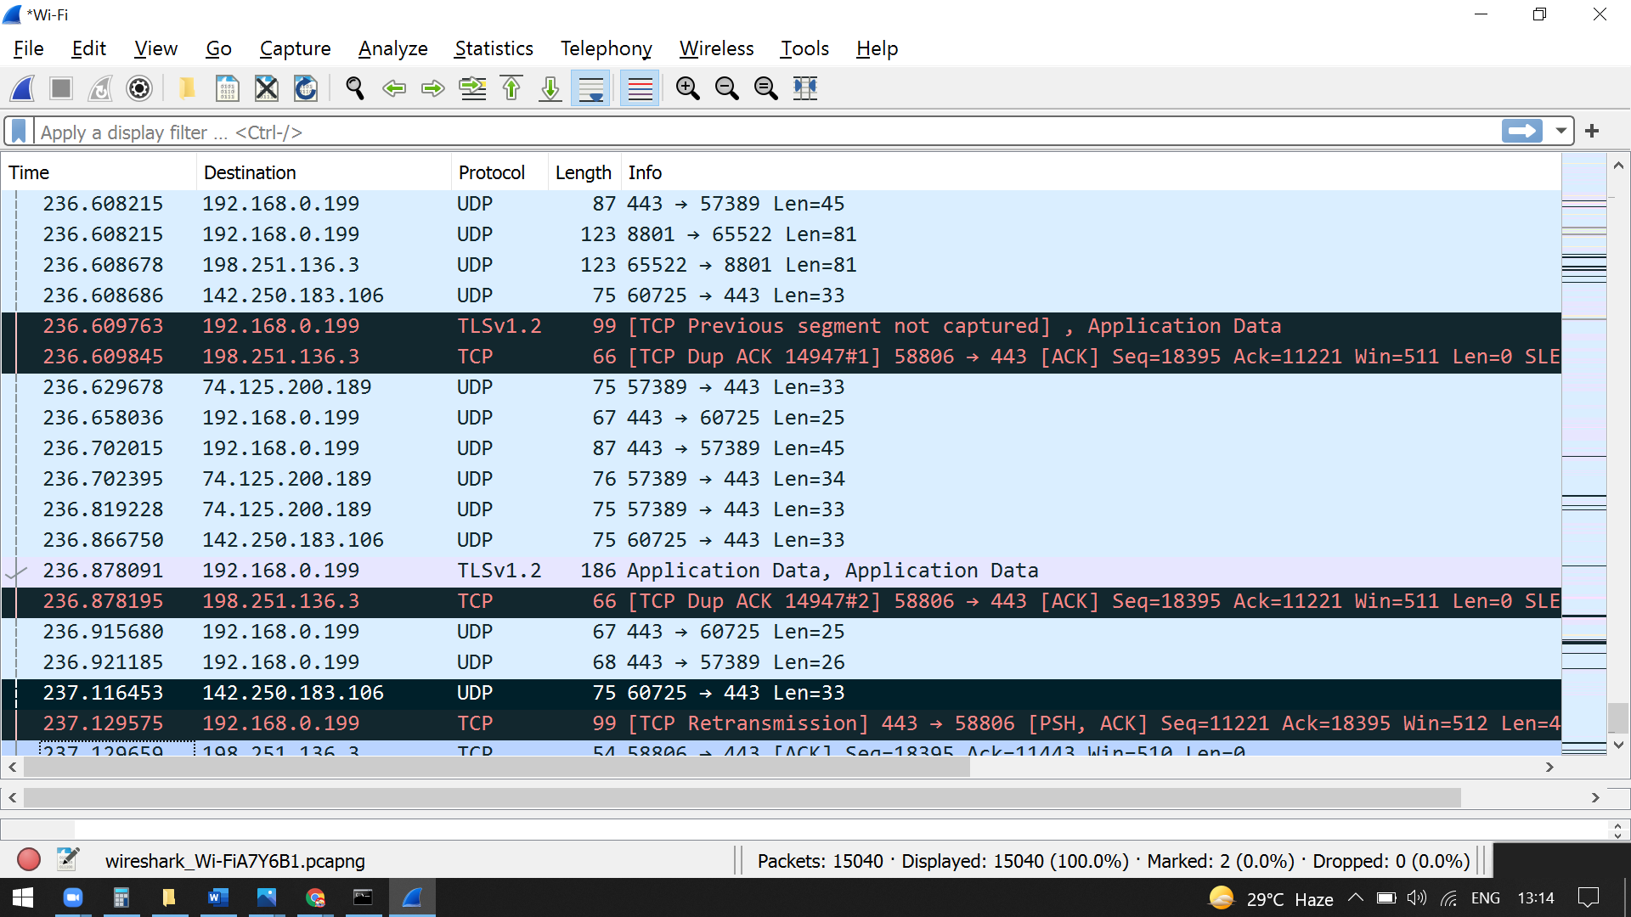

**Time references**

To work with time references, choose one of the Time Reference items in the menu:[Edit] menu or from the pop-up menu of the “Packet List” pane. See Section 3.6, “The “Edit” Menu”. Set Time Reference (toggle) Toggles the time reference state of the currently selected packet to on or off.

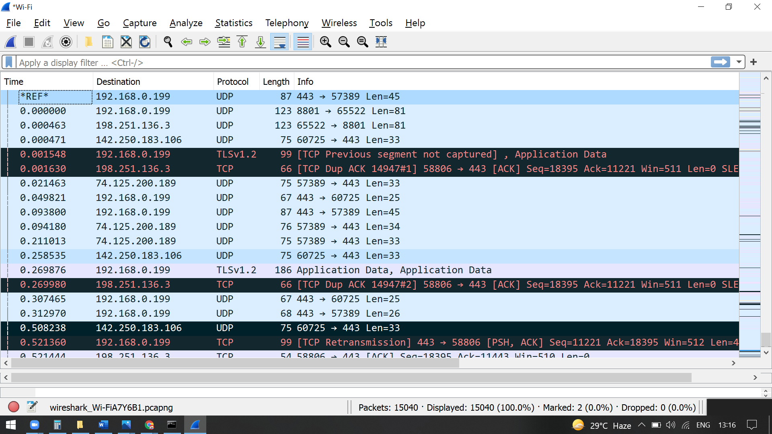

**Result:**

Hence the study about installation and the basic commands of Wireshark is done.

| **Ex. No : 2**  **Date:** | **Filtering and decoding traffic with Wireshark** |
| --- | --- |

**Aim**

To Filter and decode traffic with Wireshark

**Procedure for filtering and decoding traffic with Wireshark**

**Capture filter**

Capture filters (like tcp port 80) are not to be confused with display filters (like tcp.port == 80). The former are much more limited and are used to reduce the size of a raw packet capture. The latter are used to hide some packets from the packet list. Capture filters are set before starting a packet capture and cannot be modified during the capture. Display filters on the other hand do not have this limitation and you can change them on the fly. In the main window, one can find the capture filter just above the interfaces list and in the interfaces dialog. The display filter can be changed above the packet list as can be seen in this picture:

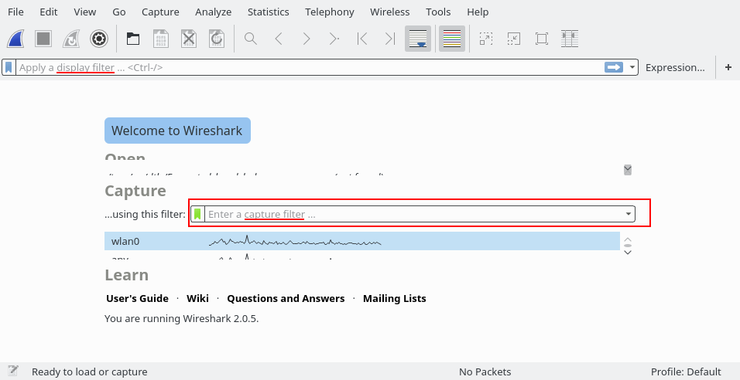

## Examples

Capture only traffic to or from IP address 172.18.5.4:

host 172.18.5.4

Capture traffic to or from a range of IP addresses:

net 192.168.0.0/24

or

net 192.168.0.0 mask 255.255.255.0

Capture traffic from a range of IP addresses:

src net 192.168.0.0/24

or

src net 192.168.0.0 mask 255.255.255.0

Capture traffic to a range of IP addresses:

dst net 192.168.0.0/24

or

dst net 192.168.0.0 mask 255.255.255.0

Capture only DNS (port 53) traffic:

port 53

Capture non-HTTP and non-SMTP traffic on your server (both are equivalent):

host www.example.com and not (port 80 or port 25)

host www.example.com and not port 80 and not port 25

Capture except all ARP and DNS traffic:

port not 53 and not arp

Capture traffic within a range of ports

(tcp[0:2] > 1500 and tcp[0:2] < 1550) or (tcp[2:2] > 1500 and tcp[2:2] < 1550)

or, with newer versions of libpcap (0.9.1 and later):

tcp portrange 1501-1549

Capture only Ethernet type EAPOL:

ether proto 0x888e

Reject ethernet frames towards the Link Layer Discovery Protocol Multicast group:

not ether dst 01:80:c2:00:00:0e

Capture only IPv4 traffic - the shortest filter, but sometimes very useful to get rid of lower layer protocols like ARP and STP:

ip

Capture only unicast traffic - useful to get rid of noise on the network if you only want to see traffic to and from your machine, not, for example, broadcast and multicast announcements:

not broadcast and not multicast

Capture IPv6 "all nodes" (router and neighbor advertisement) traffic. Can be used to find rogue RAs:

dst host ff02::1

Capture HTTP GET requests. This looks for the bytes 'G', 'E', 'T', and ' ' (hex values 47, 45, 54, and 20) just after the TCP header. "tcp[12:1] & 0xf0) >> 2" figures out the TCP header length. From Jefferson Ogata via the [tcpdump-workers mailing list](http://seclists.org/tcpdump/2004/q4/95).

port 80 and tcp[((tcp[12:1] & 0xf0) >> 2):4] = 0x47455420

## Useful Filters

Blaster and Welchia are RPC worms.

[Blaster worm](http://www.sans.org/security-resources/malwarefaq/w32_blasterworm.php):

dst port 135 and tcp port 135 and ip[2:2]==48

[Welchia worm](http://securityresponse.symantec.com/avcenter/venc/data/detecting.traffic.due.to.rpc.worms.html):

icmp[icmptype]==icmp-echo and ip[2:2]==92 and icmp[8:4]==0xAAAAAAAA

The filter looks for an icmp echo request that is 92 bytes long and has an icmp payload that begins with 4 bytes of A's (hex). It is the signature of the welchia worm just before it tries to compromise a system.

Many worms try to spread by contacting other hosts on ports 135, 445, or 1433. This filter is independent of the specific worm instead it looks for SYN packets originating from a local network on those specific ports. Please change the network filter to reflect your own network.

dst port 135 or dst port 445 or dst port 1433 and tcp[tcpflags] & (tcp-syn) != 0 and tcp[tcpflags] & (tcp-ack) = 0 and src net 192.168.0.0/24

[Heartbleed Exploit](https://web.archive.org/web/20140419183909/http:/www.riverbed.com/blogs/Retroactively-detecting-a-prior-Heartbleed-exploitation-from-stored-packets-using-a-BPF-expression.html):

tcp src port 443 and (tcp[((tcp[12] & 0xF0) >> 4 ) * 4] = 0x18) and (tcp[((tcp[12] & 0xF0) >> 4 ) * 4 + 1] = 0x03) and (tcp[((tcp[12] & 0xF0) >> 4 ) * 4 + 2] < 0x04) and ((ip[2:2] - 4 * (ip[0] & 0x0F) - 4 * ((tcp[12] & 0xF0) >> 4) > 69))

Display filter

Capture filters (like tcp port 80) are not to be confused with display filters (like tcp.port == 80).

## Examples

Show only [SMTP](https://wiki.wireshark.org/SMTP) (port 25) and [ICMP](https://wiki.wireshark.org/ICMP) traffic:

tcp.port eq 25 or icmp

Show only traffic in the LAN (192.168.x.x), between workstations and servers – no Internet:

ip.src==192.168.0.0/16 and ip.dst==192.168.0.0/16

[TCP](https://wiki.wireshark.org/TCP) buffer full *– Source is instructing Destination to stop sending data*

tcp.window_size == 0 && tcp.flags.reset != 1

Filter on Windows *– Filter out noise, while watching Windows Client - DC exchanges*

smb || nbns || dcerpc || nbss || dns

Sasser worm: *–What sasser really did–*

ls_ads.opnum==0x09

Match packets containing the (arbitrary) 3-byte sequence 0x81, 0x60, 0x03 at the beginning of the [UDP](https://wiki.wireshark.org/UDP) payload, skipping the 8-byte UDP header. Note that the values for the byte sequence implicitly are in hexadecimal only. *(Useful for matching homegrown packet protocols.)*

udp[8:3]==81:60:03

The "slice" feature is also useful to filter on the vendor identifier part (OUI) of the MAC address, see the [Ethernet](https://wiki.wireshark.org/Ethernet) page for details. Thus you may restrict the display to only packets from a specific device manufacturer. E.g. for DELL machines only:

eth.addr[0:3]==00:06:5B

It is also possible to search for characters appearing anywhere in a field or protocol by using the contains operator.

Match packets that contains the 3-byte sequence 0x81, 0x60, 0x03 anywhere in the UDP header or payload:

udp contains 81:60:03

Match packets where SIP To-header contains the string "a1762" anywhere in the header:

sip.To contains "a1762"

The matches, or ~, operator makes it possible to search for text in string fields and byte sequences using a regular expression, using Perl regular expression syntax. Note: Wireshark needs to be built with libpcre in order to be able to use the matches operator.

Match HTTP requests where the last characters in the uri are the characters "gl=se":

http.request.uri matches "gl=se$"

Note: The $ character is a PCRE punctuation character that matches the end of a string, in this case the end of http.request.uri field.

Filter by a protocol ( e.g. SIP ) and filter out unwanted IPs:

ip.src != xxx.xxx.xxx.xxx && ip.dst != xxx.xxx.xxx.xxx && sip

With Wireshark 4.0+ you can select a specific a specific occurrence of a field. To use the layer operator, just put a number sign and a layer number after a field. For example, if we have a GRE packet with both outer and inner IPv4 layers,

ip.src#1 == 10.1.2.3

will match the outer address,

ip.src#2 == 10.1.2.3

will match the inner address, and

ip.src == 10.1.2.3

will match either address

## Gotchas

Some *filter fields* match against multiple *protocol fields*. For example, "ip.addr" matches against both the [IP](https://wiki.wireshark.org/IP) source and destination addresses in the IP header. The same is true for "tcp.port", "udp.port", "eth.addr", and others. It's important to note that

ip.addr == 10.43.54.65

is equivalent to

ip.src == 10.43.54.65 or ip.dst == 10.43.54.65

This can be counterintuitive in some cases. Suppose we want to filter out any traffic to or from 10.43.54.65. We might try the following:

ip.addr != 10.43.54.65

which is equivalent to

ip.src != 10.43.54.65 or ip.dst != 10.43.54.65

This translates to "pass all traffic except for traffic with a source IPv4 address of 10.43.54.65 and a destination IPv4 address of 10.43.54.65", which isn't what we wanted.

Instead we need to negate the expression, like so:

! ( ip.addr == 10.43.54.65 )

which is equivalent to

! (ip.src == 10.43.54.65 or ip.dst == 10.43.54.65)

This translates to "pass any traffic except with a source IPv4 address of 10.43.54.65 or a destination IPv4 address of 10.43.54.65", which is what we wanted.

This can also happen if, for example, you have tunneled protocols, so that you might have two separate IPv4 or IPv6 layers and two separate IPv4 or IPv6 headers, or if you have multiple instances of a field for other reasons, such as multiple IPv6 "next header" fields.

**Filtering traffic:**

Wireshark has two filtering languages: *capture filters* and *display filters*. *Capture filters* are used for filtering when capturing packets

Capture some packets or open a previously saved capture file, you can view the packets that are displayed in the packet list pane by simply clicking on a packet in the packet list pane, which will bring up the selected packet in the tree view and byte view panes. You can then expand any part of the tree to view detailed information about each protocol in each packet. Clicking on an item in the tree will highlight the corresponding bytes in the byte view. An example with a TCP packet selected is shown in [Figure 6.1, “Wireshark with a TCP packet selected for viewing”](https://www.wireshark.org/docs/wsug_html/#ChWorkSelPack1). It also has the Acknowledgment number in the TCP header selected, which shows up in the byte view as the selected bytes.Figure 6.1. Wireshark with a TCP packet selected for viewing

| ws packet selected |
| --- |

You can also select and view packets the same way while Wireshark is capturing if you selected “Update list of packets in real time” in the “Capture Preferences” dialog box.

In addition you can view individual packets in a separate window as shown in [Figure 6.2, “Viewing a packet in a separate window”](https://www.wireshark.org/docs/wsug_html/#ChWorkPacketSepView). You can do this by double-clicking on an item in the packet list or by selecting the packet in which you are interested in the packet list pane and selecting View → Show Packet in New Window. This allows you to easily compare two or more packets, even across multiple files.

Figure 6.2. Viewing a packet in a separate window

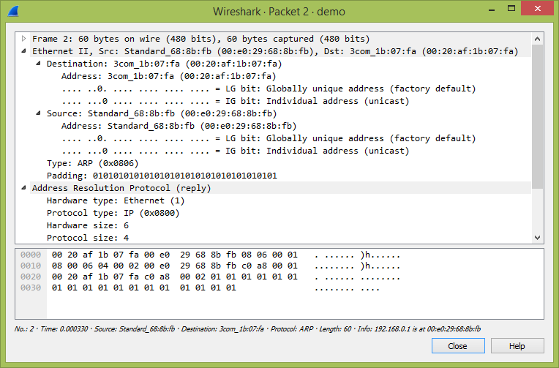

Wireshark has two filtering languages: *capture filters* and *display filters*. *Capture filters* are used for filtering when capturing packets and are discussed in [Section 4.10, “Filtering while capturing”](https://www.wireshark.org/docs/wsug_html/#ChCapCaptureFilterSection). *Display filters* are used for filtering which packets are displayed and are discussed below. For more information about *display filter* syntax, see the [wireshark-filter(4)](https://www.wireshark.org/docs/man-pages/wireshark-filter.html) man page.Display filters allow you to concentrate on the packets you are interested in while hiding the currently uninteresting ones. They allow you to only display packets based on:

* Protocol
* The presence of a field
* The values of fields
* A comparison between fields
* …​ and a lot more!

To only display packets containing a particular protocol, type the protocol name in the display filter toolbar of the Wireshark window and press enter to apply the filter. [Figure 6.8, “Filtering on the TCP protocol”](https://www.wireshark.org/docs/wsug_html/#ChWorkTCPFilter) shows an example of what happens when you type *tcp* in the display filter toolbar.

|  | Note |
| --- | --- |
| Protocol and field names are usually in lowercase. |
|  | Note |
| Don’t forget to press enter or click on the apply display filter button after entering the filter expression. |

Figure : Filtering on the TCP protocol

| ws display filter tcp |
| --- |

As you may have noticed, only packets containing the TCP protocol are now displayed, so packets 1-10 are hidden and packet number 11 is the first packet displayed.

To remove the filter, click on the Clear button to the right of the display filter field. All packets will become visible again.

Display filters can be very powerful and are discussed in further detail in [Section 6.4, “Building Display Filter Expressions”](https://www.wireshark.org/docs/wsug_html/#ChWorkBuildDisplayFilterSection)

It’s also possible to create display filters with the *Display Filter Expression* dialog box. More information about the *Display Filter Expression* dialog box is available in [Section 6.5, “The “Display Filter Expression” Dialog Box”](https://www.wireshark.org/docs/wsug_html/#ChWorkFilterAddExpressionSection).

 Display Filter Field Types

IPv4 address

ip.addr == 192.168.0.1

Classless InterDomain Routing (CIDR) notation can be used to test if an IPv4 address is in a certain subnet. For example, this display filter will find all packets in the 129.111 Class-B network:

ip.addr == 129.111.0.0/16

IPv6 address

ipv6.addr == ::1

As with IPv4 addresses, IPv6 addresses can match a subnet.

## The “Display Filter Expression” Dialog Box

When you are accustomed to Wireshark’s filtering system and know what labels you wish to use in your filters it can be very quick to simply type a filter string. However, if you are new to Wireshark or are working with a slightly unfamiliar protocol it can be very confusing to try to figure out what to type. The “Display Filter Expression” dialog box helps with this.

Figure 6.9. The “Display Filter Expression” dialog box

| ws filter add expression |
| --- |

Decoding traffic

# Decoding RTP Packets on Wireshark Manually

## Issue

Decoding RTP packets on Wireshark manually.

## Solution

Description:

Wireshark decodes video and audio packet as UDP when it comes from RTP stream.

Cause:

When the packet capture does not include H.225, Q.931 or H.245 flow of packet, Wireshark is unable to decode video and audio packet as RTP.

Resolution:

1. On the Wireshark packet list, right mouse click on one of UDP packet.
2. Select Decode As menu.
3. On the Decode As window, select Transport menu on the top.
4. Select Both on the middle of UDP port(s) as section.
5. On the right protocol list, select RTP in order to the selected session to be decoded as RTP.
6. Click OK or Apply button.
7. HTTPS is essentially an encrypted communications tunnel containing HTTP traffic. These tunnels first used Secure Sockets Layer (SSL) as an encryption protocol. Today most HTTPS traffic uses Transport Layer Security (TLS).

**HTTPS Web Traffic**

HTTPS traffic often reveals a domain name. For example, when viewing https://www.wireshark.org in a web browser, a pcap would show www.wireshark.org as the server name for this traffic when viewed in a [customized Wireshark column display](https://unit42.paloaltonetworks.com/unit42-customizing-wireshark-changing-column-display/). Following the Transmission Control Protocol (TCP) stream from a pcap will not reveal the content of this traffic because it is encrypted.

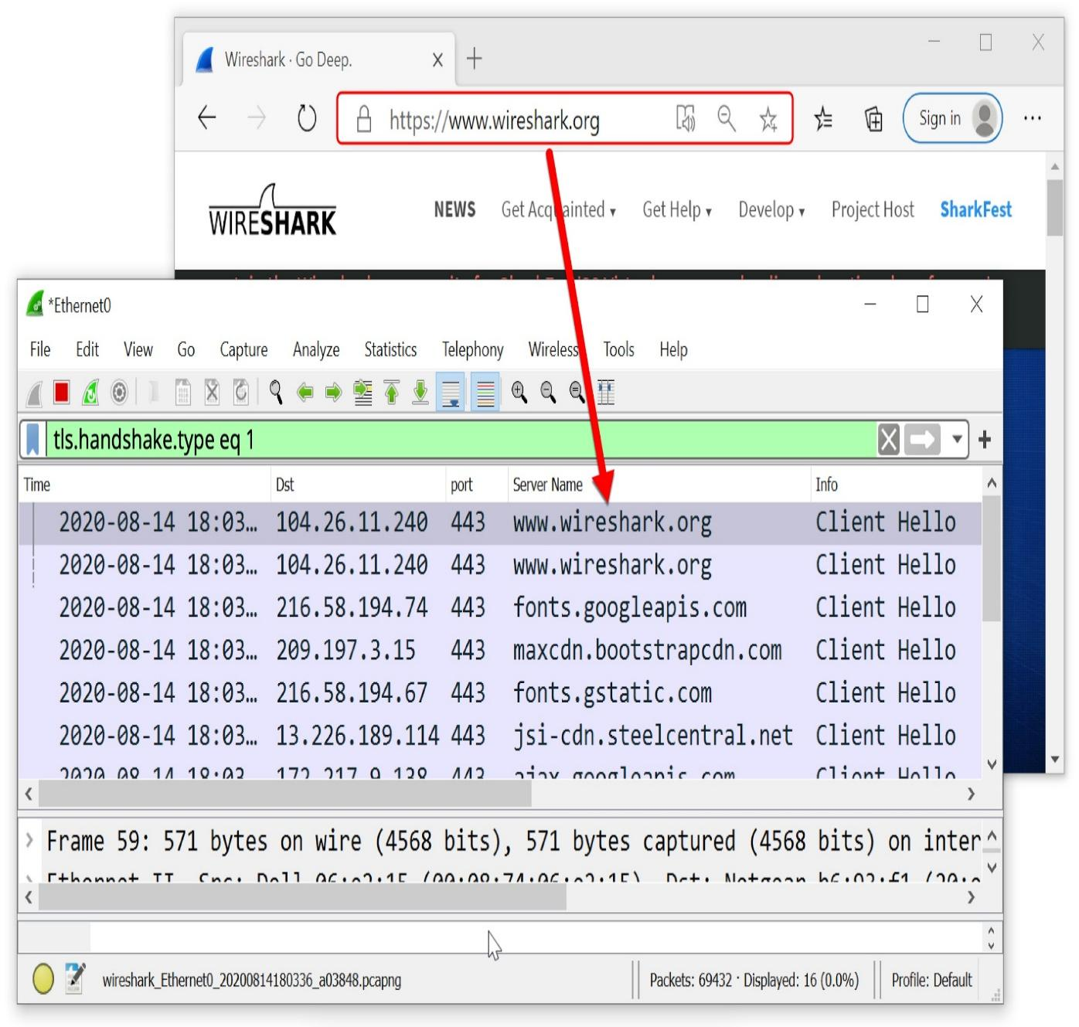 Traffic from HTTPS traffic to www.wireshark.org.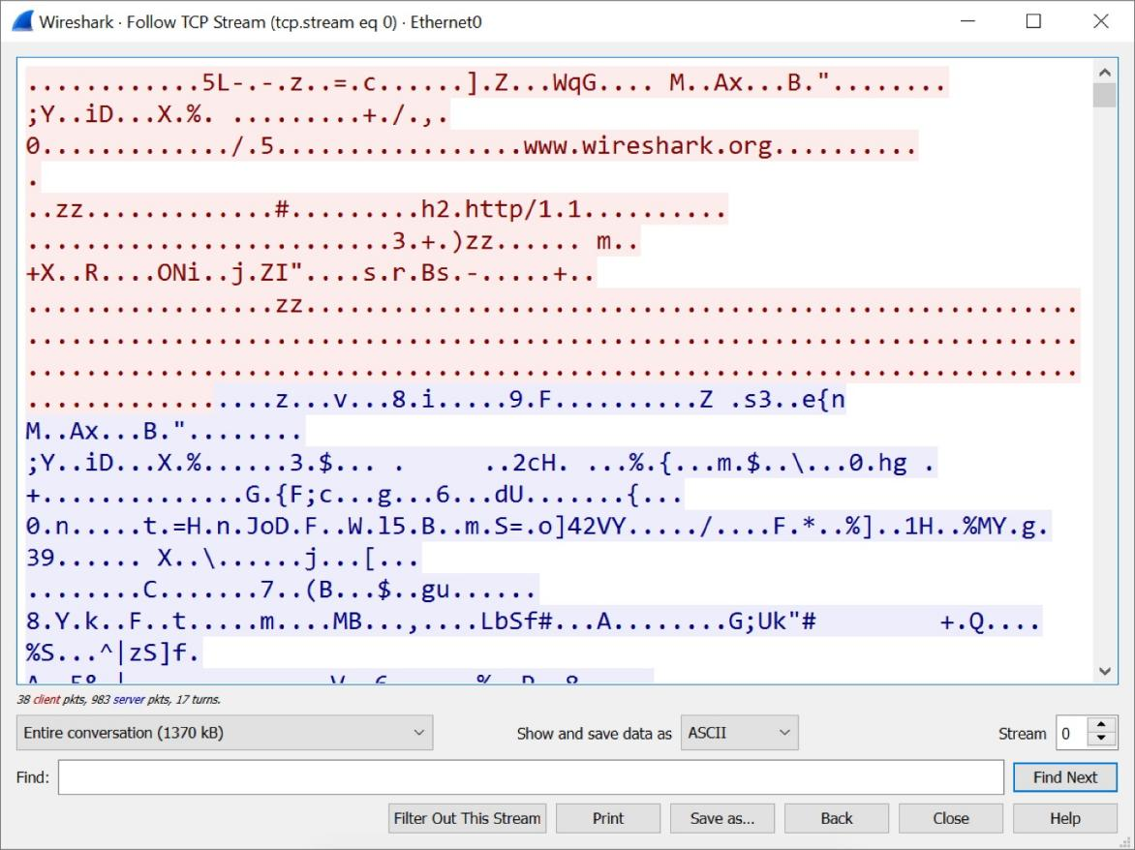

**Result:**

Hence to Filter and decode traffic with Wireshark is done and output is verified.

| **Ex. No : 5**  **Date:** | **Study the Cain and Abel tool** |
| --- | --- |

**Aim:**

To Study the Cain and Abel tool

**About the tool Cain and Abel:**

Cain & Abel is a password recovery tool for Microsoft Operating Systems. It allows easy recovery of various kind of passwords by sniffing the network, cracking encrypted passwords using Dictionary, Brute-Force and Cryptanalysis attacks, recording VoIP conversations, decoding scrambled passwords, recovering wireless network keys, revealing password boxes, uncovering cached passwords and analyzing routing protocols. The program does not exploit any software vulnerabilities or bugs that could not be fixed with little effort. It covers some security aspects/weakness present in protocol’s standards, authentication methods and caching mechanisms; its main purpose is the simplified recovery of passwords and credentials from various sources, however it also ships some “non-standard” utilities for Microsoft Windows users.

**Step 1:**

Please turn off the windows firewall or any other third party firewall so that all the packets are captured efficiently.

**Step 2:**

Open Cain and Abel tool

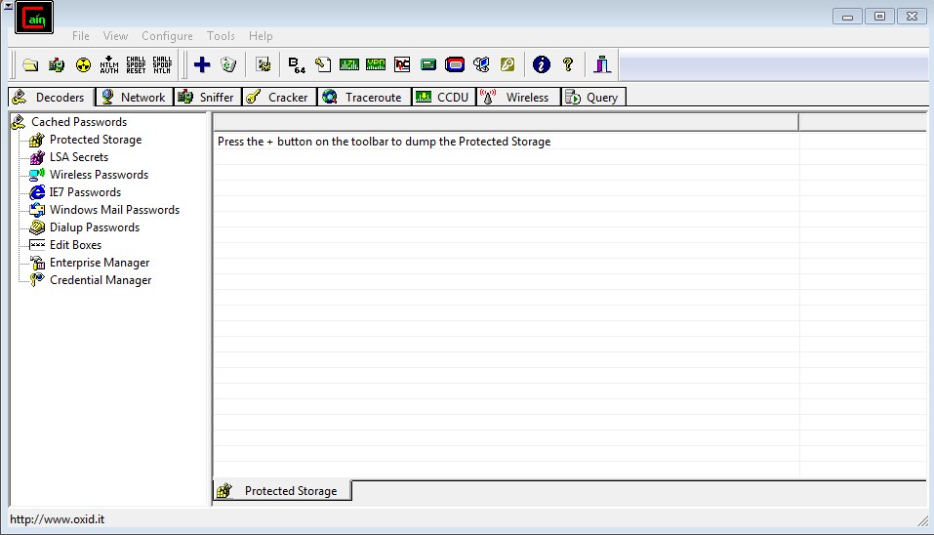

**Step 3:**

Goto -> Sniffer Tab and click Configure in the main menu to configure your packet listening adapter.

**Step4:**  
Select the appropriate network adapter for your network that you want to sniff the packets for plain-text passwords. And Click Ok.

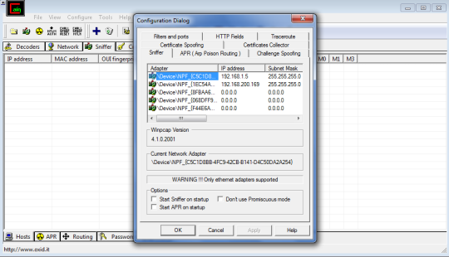

**Step5:**  
Click the Green Adapter icon as shown below. This means that you just configured the adapter and now you are turning it ON.

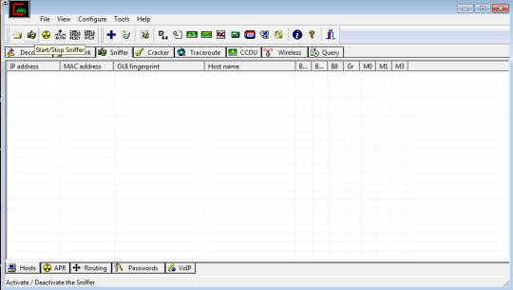

**Step 6:**  
Now select the APR tab below as shown and now first click on the right side upper pane area. When you click that area the blue plus (“+”) icon will get enabled. Press that blue plus (“+”) icon.

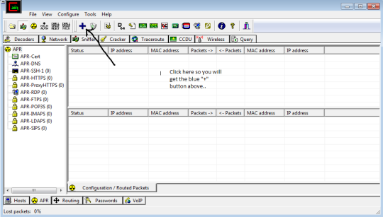

**Step 7:**

This is very interesting step. Now we need to select the router`s IP address and click ok. This means that we want to listen to every packet that is sent to router. If we select any other IP address in our LAN network then we can listen to only that particular HOST on the network. Since the router responds to all the request of HOSTS connected in a LAN. Thus we can listen to all the HOSTs.

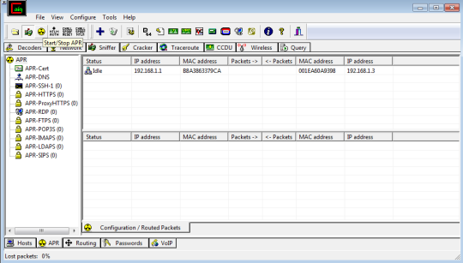

**Step8:**  
Now click the Yellow Circle icon as shown. This means that we are starting ARP poisoning.

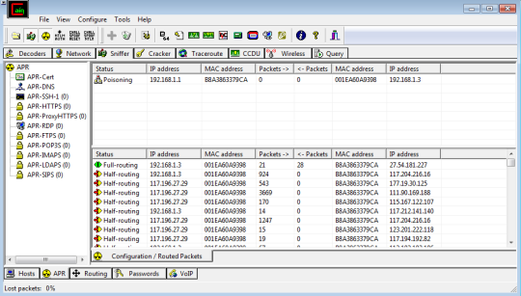

**Step9:**  
We can see that in the upper right panel there is an IP address of our router and when we press that Yellow Circle icon (button), it performs ARP poisoning.

**Step10:**  
Now click the password tab which is at the bottom. We can see that we are getting passwords of HTTP i.e. plain text session in our LAN network.

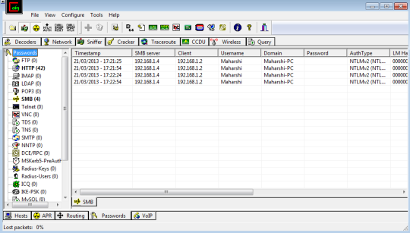

 Note: While performing this practical you will notice that there is significant reduction in the network speed. This is due to the fact that ARP spoofing on the LAN network creates many fake packets advertising other`s host identity.

This can also create DoS Attack on the LAN network as it creates many fake packets for processing thereby making unable for other HOST to make a request on the network.

**Result:**

Hence to Study the Cain and Abel tool is proved.

| **Ex. No : 6**  **Date:** | **Identification ARP and capture with pcap file in wireshark** |
| --- | --- |

**Aim**

To identify ARP and save with .pcap file in wireshark

**Procedure:**

Arp -a :-

The Address Resolution Protocol (ARP) maps internet addresses to hardware addresses. TCP/IP uses ARP to collect and distribute the information for mapping

Start a Wireshark capture. Use arp -d to clear the ARP cache. Use ping <default gateway address> to ping the default gateway address. Use arp -a to view the ARP cache and confirm an entry has been added for the default gateway address.







There are several ways to mark and unmark packets. From the Edit menu you can select from the following:

* Mark/Unmark Packet toggles the marked state of a single packet. This option is also available in the packet list context menu.
* Mark All Displayed set the mark state of all displayed packets.
* Unmark All Displayed reset the mark state of all packets.



**ARP Spoofing**

* The ARP protocol was not designed for security, so it does not verify that a response to an ARP request really comes from an authorized party.
* It also lets hosts accept ARP responses even if they never sent out a request. This is a weak point in the ARP protocol, which opens the door to ARP [spoofing attacks](https://www.imperva.com/learn/ddos/ip-spoofing/).

An ARP spoofing, also known as ARP poisoning, is a [Man in the Middle](https://www.imperva.com/learn/application-security/man-in-the-middle-attack-mitm/) (MitM) attack that allows

# **Saving Captured Packets in Wireshark**

In Wireshark, after capturing some traffic of a network we can save the capture file on our local device so that it can be analyzed thoroughly in the future. We can save captured packets by using the File → Save or File → Save As…​ menu items. This will bring up the “Save Capture File As” dialogue box. While saving, we can select some specific packets and also choose different file formats according to our use. But most of the file formats don’t record the number of dropped packets.

If we are exiting without saving the current capture file then we will be prompted with a message to save the file first to prevent data loss. This warning can be disabled in the preferences. Wireshark uses the pcapng file format as the default format to save captured packets.

**Save Capture File As Dialogue Box:**

The “Save Capture File As” dialogue box allows us to save the current capture to a file in our local system. The appearance of this dialogue box varies from system to system, but the functionality is the same across all systems.

* Windows:

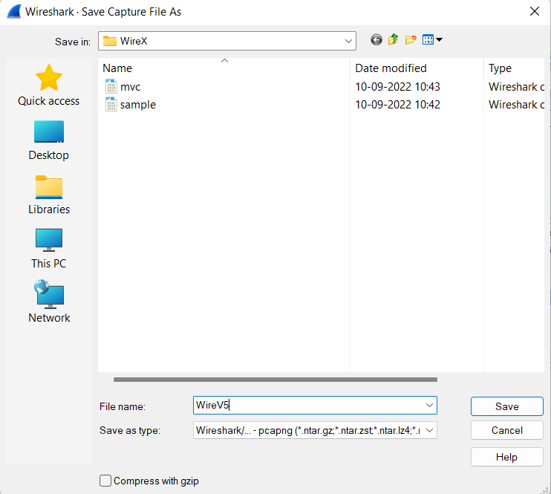

While saving, we can decide on many formats of the capture file by clicking on the “Save as” drop-down box. Below are the following file formats in which a capture file can be saved by Wireshark :

* pcap: The libpcap packet capture library uses pcap as the default file format.  The tcpdump, _Snort, Nmap, and Ntop also use pcap as the default file format.
* pcapng: Wireshark 1.8 or later uses the pcapng file format as the default format to save captured packets.
* Microsoft Network Monitor: NetMon (*.cap)
* Network Associates Sniffer:  DOS (*.cap,*.enc,*.trc,*.fdc,*.syc), Windows (*.cap)
* Cinco Networks NetXray captures (*.cap
* Novell LANalyzer (*.tr1)
* Oracle (previously Sun) snoop (*.snoop,*.cap)
* Visual Networks Visual UpTime traffic (*.*)
* Symbian OS btsnoop captures (*.log)

Some file formats may not be available depending on the packet types captured. The “Compress with gzip” option will compress the capture file as it is being written to disk. We can also convert a capture file format to another format by opening it and saving it in a different format.

**Result:**

Hence to identify ARP and save with .pcap file in wireshark is done and output is verified.

| **Ex. No : 7**  **Date:** | **Implement of Data Encryption Standard (DES) using block cipher modes** |
| --- | --- |

**Aim:**

To Implement of Data Encryption Standard (DES) using various block cipher modes

**Algorithm:**

STEP-1: Read the 64-bit plain text.

STEP-2: Split it into two 32-bit blocks and store it in two different arrays.

STEP-3: Perform XOR operation between these two arrays.

STEP-4: The output obtained is stored as the second 32-bit sequence and the original second 32-bit sequence forms the first part.

STEP-5: Thus the encrypted 64-bit cipher text is obtained in this way. Repeat the same process for the remaining plain text characters.

**Program:**

from Crypto.Cipher import DES

from secrets import token_bytes

key = token_bytes(8)

def encrypt(msg):

cipher = DES.new(key, DES.MODE_EAX)

nonce = cipher.nonce

ciphertext, tag = cipher.encrypt_and_digest(msg.encode('ascii'))

return nonce, ciphertext, tag

def decrypt(nonce, ciphertext, tag):

cipher = DES.new(key, DES.MODE_EAX, nonce=nonce)

plaintext = cipher.decrypt(ciphertext)

try:

cipher.verify(tag)

return plaintext.decode('ascii')

except:

return False

nonce, ciphertext, tag = encrypt(input('Enter a message: '))

plaintext = decrypt(nonce, ciphertext, tag)

print(f'Cipher text: {ciphertext}')

if not plaintext:

print('Message is corrupted!')

else:

print(f'Plain text: {plaintext}')

**Output:**

PS C:\Users\ Desktop\NS lab> python main.py

Enter a message:srm ktr

Cipher text: b'\x96\xa2\xc2\xbd\r\x0bY\xce\xc7\x05\x1e\xeb\xb4fN\xbcSH\xb5\x0f4\x80\xbb\x84e\n\xe1\xc3\xf6\x8f\x83\xb9\xa4\xc0\xfc\xa5P\x839\x7f\xfc\xcdL\xe1\xee\x87+\x88\xd2\xc1P\xb9\x03\xaa\xdf~1\x1b$p\xdb\xb6W\xa7\x93\x11y\xac\xc64\x01\xc1\xacy\xc3\xa1\\\xda\xdb<i"n\xb4)\xec}\x1bt\x1f\xc2\'\xf74\x10\x072f\x15\x8altk\x01\x8a|\x19\\\xfa5\xb0\xe6x\xce\xd6>\xdcMV\xdf{R\x00\xe6\x11z1\x0c'

Signature: b'\x87\x1d){<\xb9\xfc\x8a\x05.\x1cw\xfd3\xeb\x88,>\xa6\xbfy2a\xa1\x1f]\x17{F\xbb\x13%\xbc\xdf\x1c\xdd\x05)\xfb\xcb\xc3\x97\xf1\x8eu\xc0)\x7fO\x0b\xa5\xde\xca7\t\xe9-K(~\xa1\x9a\x18\xe4P\xc2zN\xb5\xe4\xf44\x81o\xcb\x94+\xea_kA\x04(+d\x89~\xb1\x9fp\xf9F{\xdc%[\x1f\x9c(\xd4\x82\x8d\x05\x1fm\xeb\xb6\xf3\xdd\xf86$s\x1e\xc31~\xe5\x9a\x00m\xd7\xf7o!0b\xfb'

Plain text: srm ktr

Signature verified!

**Result:**

Hence to Implement of Data Encryption Standard (DES) using various block cipher modes is

done and output is verified.

| **Ex. No : 6**  **Date:11/10/22** | **Implementation of Advanced Encryption Standard (AES)** |
| --- | --- |

**Aim:**

To Implement of Advanced Encryption Standard (AES) .

**Algorithm:**

Step 1: AES is based on a design principle known as a substitution–permutation.

Step 2: AES does not use a Feistel network like DES, it uses variant of Rijndael.

Step 3: It has a fixed block size of 128 bits, and a key size of 128, 192, or 256 bits.

Step 4: AES operates on a 4 × 4 column-major order array of bytes, termed the state

**Program:**

from Crypto.Cipher import AES

from secrets import token_bytes

key = token_bytes(16)

def encrypt(msg):

cipher = AES.new(key, AES.MODE_EAX)

nonce = cipher.nonce

ciphertext, tag = cipher.encrypt_and_digest(msg.encode('ascii'))

return nonce, ciphertext, tag

def decrypt(nonce, ciphertext, tag):

cipher = AES.new(key, AES.MODE_EAX, nonce=nonce)

plaintext = cipher.decrypt(ciphertext)

try:

cipher.verify(tag)

return plaintext.decode('ascii')

except:

return False

nonce, ciphertext, tag = encrypt(input('Enter a message: '))

plaintext = decrypt(nonce, ciphertext, tag)

print(f'Cipher text: {ciphertext}')

if not plaintext:

print('Message is corrupted')

else:

print(f'Plain text: {plaintext}'

**Output:**

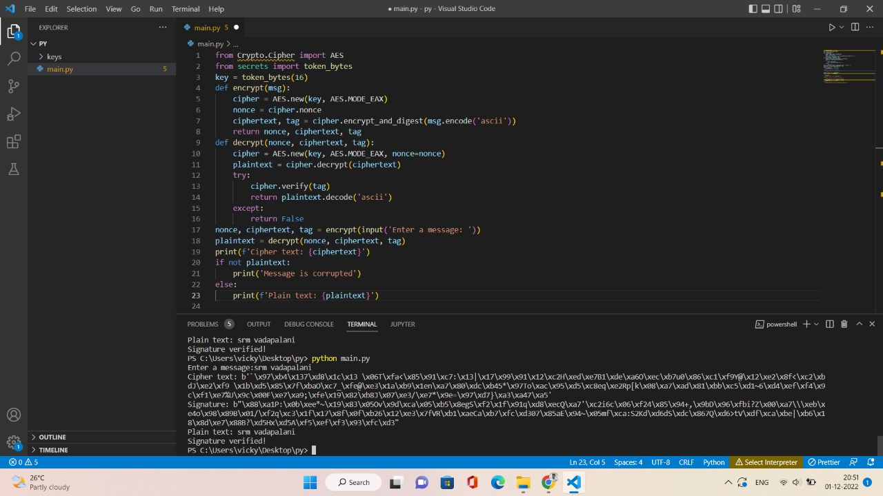

**Result:**

Hence to Implement Advanced Encryption Standard (AES) is done and output is verified.

| **Ex. No : 7**  **Date:18/10/22** | **Implementation of Rivest–Shamir–Adleman (RSA) algorithm** |
| --- | --- |

**Aim:**

To Implement Rivest–Shamir–Adleman (RSA) algorithm

**Algorithm:**

Step 1: Choose two prime number p and q

Step 2: Compute the value of n and p

Step 3: Find the value of e (public key)

Step 4: Compute the value of d (private key) using gcd()

Step 5: Do the encryption and decryption

a. Encryption is given as, c = te mod n

b. Decryption is given as, t = cd mod n

**Program:**

import rsa

def generate_keys():

(pubKey, privKey) = rsa.newkeys(1024)

with open('keys/pubkey.pem', 'wb') as f:

f.write(pubKey.save_pkcs1('PEM'))

with open('keys/privkey.pem', 'wb') as f:

f.write(privKey.save_pkcs1('PEM'))

def load_keys():

    with open('keys/pubkey.pem', 'rb') as f:

      pubKey = rsa.PublicKey.load_pkcs1(f.read())

    with open('keys/privkey.pem', 'rb') as f:

        privKey = rsa.PrivateKey.load_pkcs1(f.read())

    return pubKey, privKey

def encrypt(msg, key):

return rsa.encrypt(msg.encode('ascii'), key)

def decrypt(ciphertext, key):

try:

return rsa.decrypt(ciphertext, key).decode('ascii')

except:

        return False

def sign_sha1(msg, key):

    return rsa.sign(msg.encode('ascii'), key, 'SHA-1')

def verify_sha1(msg, signature, key):

    try:

        return rsa.verify(msg.encode('ascii'), signature, key) == 'SHA-1'

    except:

        return False

generate_keys()

pubKey, privKey = load_keys()

message = input('Enter a message:')

ciphertext = encrypt(message, pubKey)

signature = sign_sha1(message, privKey)

plaintext = decrypt(ciphertext, privKey)

print(f'Cipher text: {ciphertext}')

print(f'Signature: {signature}')

if plaintext:

    print(f'Plain text: {plaintext}')

else:

    print('Could not decrypt the message.')

if verify_sha1(plaintext, signature, pubKey):

    print('Signature verified!')

else:

    print('Could not verify the message signature.')

**Output:**

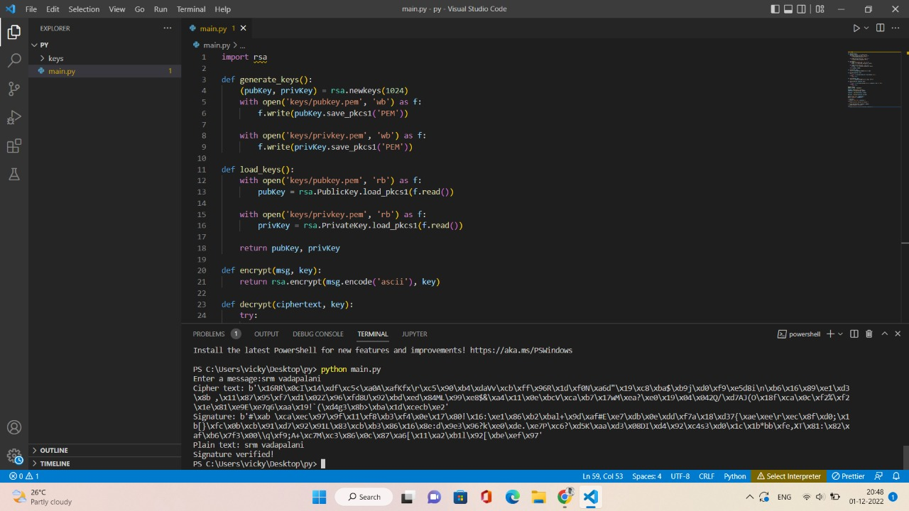

**Result:**

Hence to Implement Rivest–Shamir–Adleman (RSA) algorithm is done and output is verified

| **Ex. No :**  **Date** | **Creating a Virtual install of Kali using Virtual Box** |
| --- | --- |

**Aim:**

**To study for creating a Virtual install of Kali using Virtual Box**

**Caveat**

Be sure to read through the lab in its entirety before starting this or any lab in the course! Skipping a step in any part of the lab will cause the lab to fail. Trying to blow through this lab will result in epic failure! Slow and steady wins the race.

**Requirements:**

1. Kali Linux Preinstalled Image: (~3.01 GB)
2. VirtualBox: (~107 MB)
3. CPU that supports Virtualization.
4. 8GB of RAM preferred. (4 GB of RAM will Suffice but is not optimal)
5. At least 60 GB of free hard drive space. (An external hard drive or thumb drive can also be used as storage)

**Using Other Hypervisors**

For all the gunslingers in the course, if you are using some other hypervisor to create your virtual lab environment, you are good to go. No need to check with the instructor.

This lab will walk through the creation and installation of a Kali Linux virtual machine inside VirtualBox using a prebuilt image. Kali will function as our attack machine for all subsequent labs.

Install using a prebuilt Kali VB Image (preferred)

This install process can take as much time your resources will allow or depending on the specifics of your situation, i.e., computer, internet connection speed, and so on.

All the software used in the lab is free and open-source, just like Kali.

As the lab begins, students will be taken through the download process for all downloads. All software has been verified to be malware and crapware free.

Install Kali Linux in VirtualBox (using ova file)

1. Download and install VirtualBox

The first step is to download and install the VirtualBox software package onto the host machine chosen for your lab setup. Make sure you download the right version for your operating system and hardware architecture (32 bit vs. 64 bit). Instructions for installation on various operating systems are readily available if you run into any snags. Also, make sure to keep a handy copy of the [VirtualBox user manual](https://www.virtualbox.org/wiki/Documentation), which comes packaged with the software and can also be found online.

Once downloaded, VirtualBox installs like any other software program. Find your download and begin installing it. VirtualBox is malware and crapware free. Once you install VirtualBox and run it for the first time, you'll be presented with the application's welcome prompt, which provides an orientation for the interface. Navigate through the menus to get a feel for the software.

[Download here!](https://www.virtualbox.org/)

2. Download and install Free Download Manager(optional step)

Download managers allow you to schedule, start, stop, and resume a download without loss of any downloaded progress. When we are downloading gigabytes of data, being almost done and having the download interrupted and having to start over is very frustrating. Download managers can also reduce your download time.

For this lab, I used a download manager called Free Download Manager.

Install the Free Download Manager on your host machine. Find your download and begin installing it. The Free Download Manager is malware and crapware free.

[Download here!](http://www.freedownloadmanager.org/)

3. Download the Kali VirtualBox image

Using a pre-installed file saves us a lot of time as we won't have to step through the installation process.

For this install method, we need to use the Free Download Manager to ensure our download is uninterrupted and timely.

Since the Kali images are updated over time, the file for the download will differ from what is in the lab, but it remains the same file, just with updates. Visit the [Offensive Security download page](https://www.offensive-security.com/kali-linux-vm-vmware-virtualbox-image-download/) for the latest image.

Once you're on the right download page, your choice if which download to choose from is either number 1 or number 2. If your system 64bit, use the first download. If your system is 32 bit, use the other download. Select your download method.

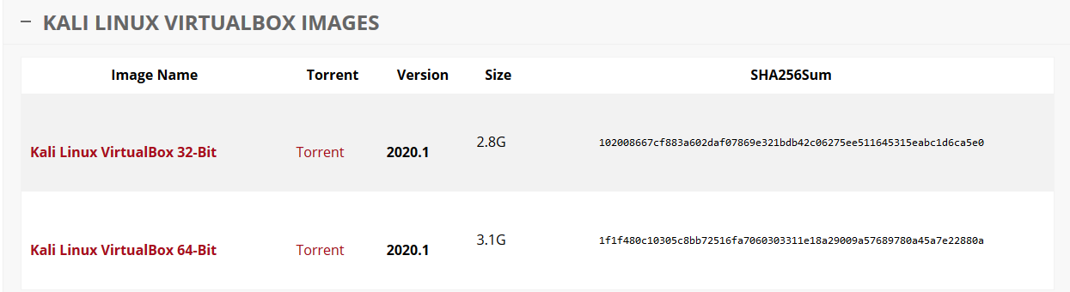

If your Free Download Manager is associated with your browser, it should automatically open and prompt you to start the download. If not, just right click on the download method and select, Copy link location. Download Manager can also use torrents.

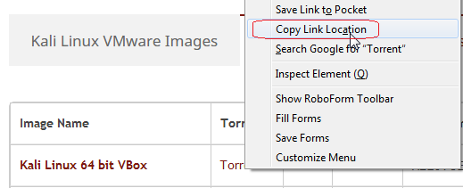

Open your Free Download Manager and click on the + sign in the upper left corner. The Add Download box appears. The link is already inserted. Click, OK, the download starts.

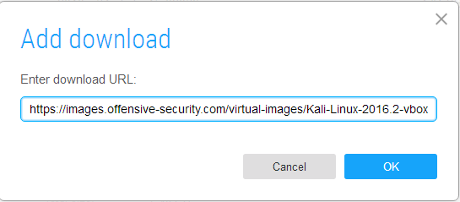

I choose to use a torrent, so I get a dialog box letting me know what it is I am downloading. Click download.

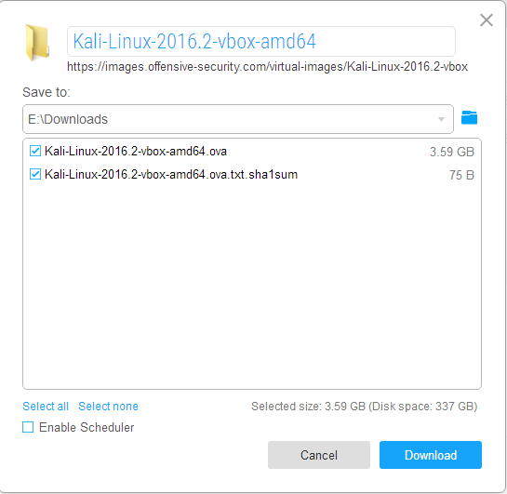

As the torrent starts connecting to other peers, the time begins to drop drastically. As the speed increases, the time to download decreases. After just a few minutes, the download will settle in at roughly 27 minutes. Your ISP may block torrent files, or the torrent may download corrupted files. If either happens, you will need to use the straight download with the Free Download Manager.

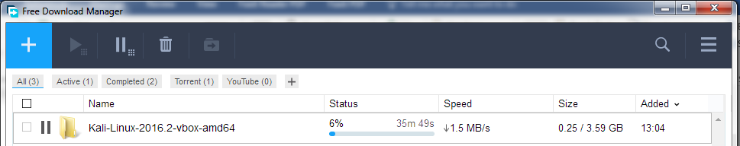

Once the download has been completed, browse over to the download location where the image was saved.

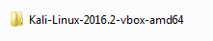

Open the folder and inside, double-click the OVA file.

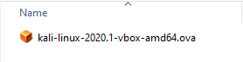

VirtualBox opens and is ready to import Kali. Click on Import.

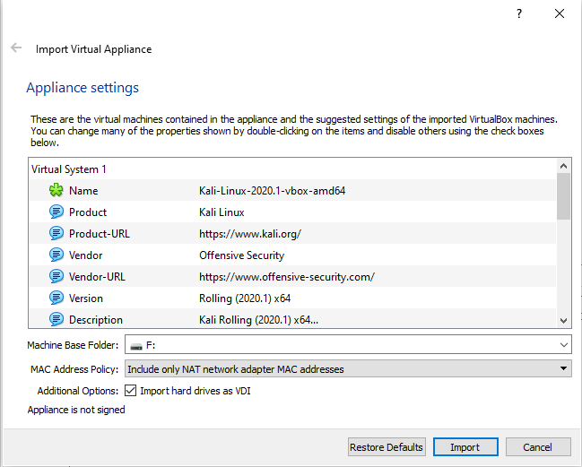

Agree to the terms.

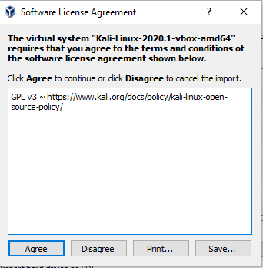

The image is imported.

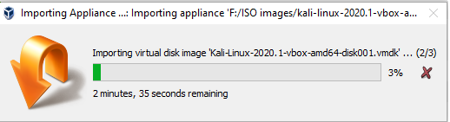

Once the image has been imported, from the left Windows pane, highlight Kali, and click on the green Start arrow.

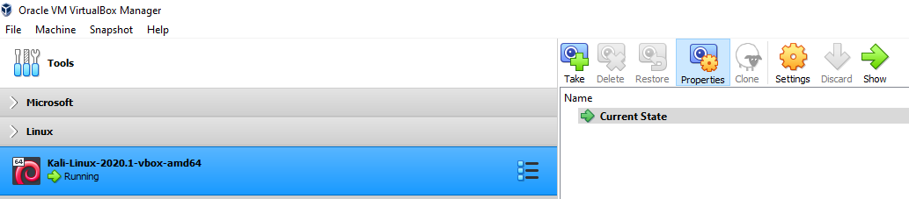

When Kali starts to boot, select the default install option, and hit enter.

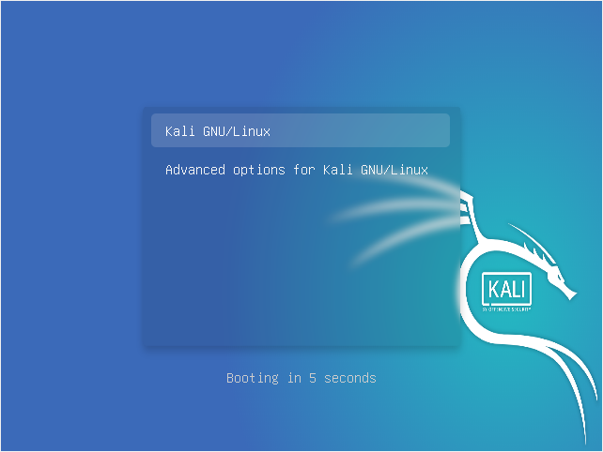

Username and password update for Kali 2020.1

Starting with Kali Linux 2020.1, the ethical hacking Linux distribution has replaced the default root user with a standard, unprivileged user. The new default user is kali, with a default password of kali.

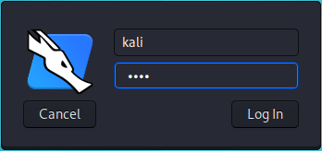

virtual instance of Kali Linux installed

Stop Kali from logging you off for inactivity

After being idle for just 5 minutes, Kali will you log off. To get back to the login box, hit the enter key. Type in your password of kali

To prevent this from happening, we can adjust the power setting to never. At the top right corner, click on the lightning bolt icon for the power settings.

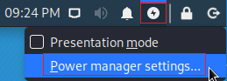

Click on the Power program.

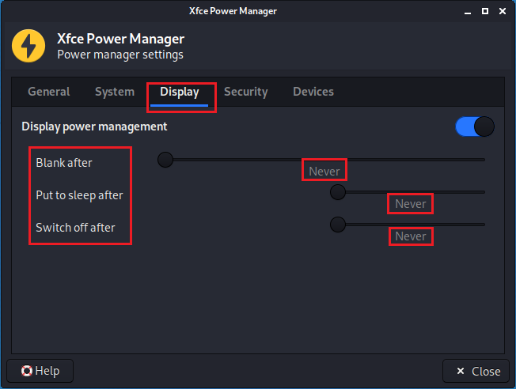

Under Display, move all three sliders to the left and select 'never.'

Under Security,

* From the drop-down window, select "Automatically lock this session" to "Never."
* Uncheck "Lock screen when system is going to sleep."

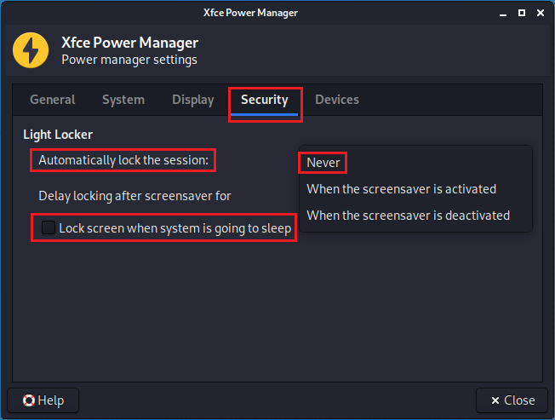

Close the Power Manager window.

How to Restart of Power Off Kali Gracefully

To shut down or restart Kali, do it just as if you were gracefully shutting down or restarting your host machine. Do not just power off VirtualBox as this will corrupt your Kali install!

To log-off, restart, or shutdown, from the top right of your Kali screen, click on the power button icon.



The following screen pops up, select your option.

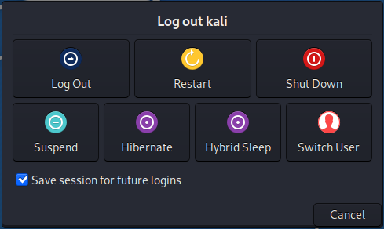

**Result:**

Hence to create a Virtual install of Kali using Virtual Box is done.

| **Ex. No :**  **Date:** | **Snort Tool in Different Modes** |
| --- | --- |

**Aim:**

To study the Snort tool in different modes.

**Introduction to Snort:**

In this tutorial we will look at installing and configuration of snort on Windows 10. Snort is an open source and popular Intrusion Detection System (IDS). It works by actively monitoring of network traffic parsing each packet and alerting system administrator of any anomalous behavior that goes against the snort rules configured by the administrator according to the security policies of an organization.

1. Installing Snort 2.9.17 on Windows 10 a Step By Step Guide:

For Windows 10 64 bit supported SNORT’s executable file can be downloaded from here.

2. Open the downloaded snort executable file.

3. Click On ‘I Agree’ on the license agreement.

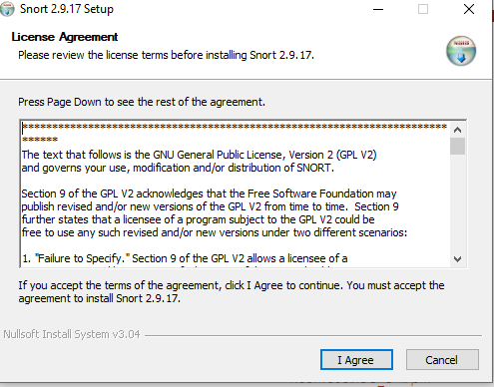

Figure 01: License agreement for Snort 2.9.17

4. Choose components of Snort to be installed.

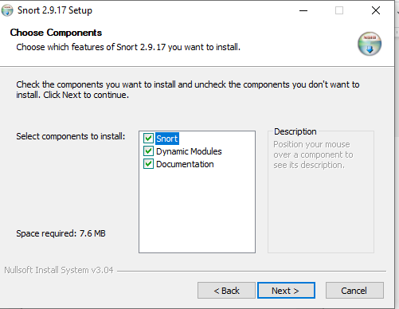

5. Click “Next” and then choose install location for snort preferably a separate folder in Windows C Drive.

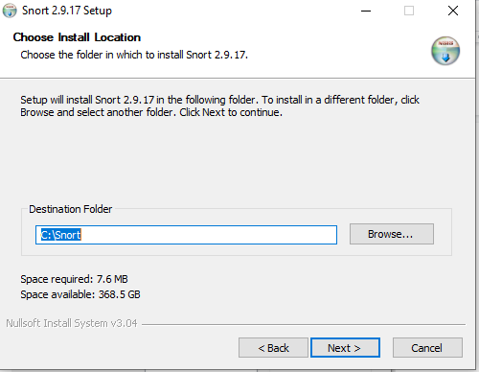

6. Click “Next” Installation process starts and then it completes as shown in figure 04:

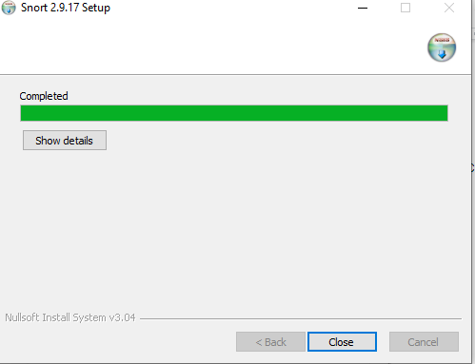

7. When you click “Close” you are prompted with this dialogue box:

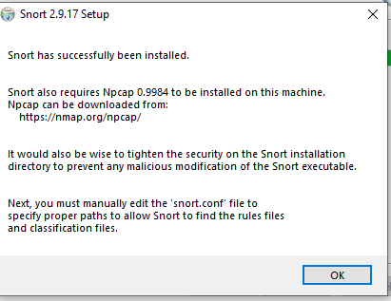

8. Installing Npcap is required by snort for proper functioning.

9. Npcap for Windows 10 can be downloaded from [here](https://nmap.org/npcap/).

10. Opening Npcap setup file, Click on ‘I Agree’ To license agreement.

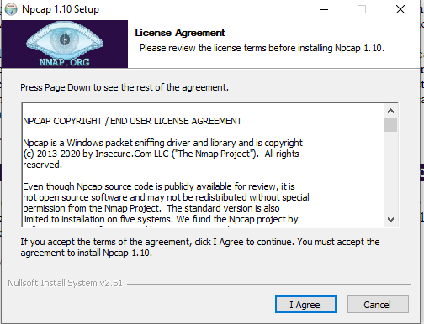

11. Now we proceed to choose which components of Npcap are to be installed and then clicking on “Install”.

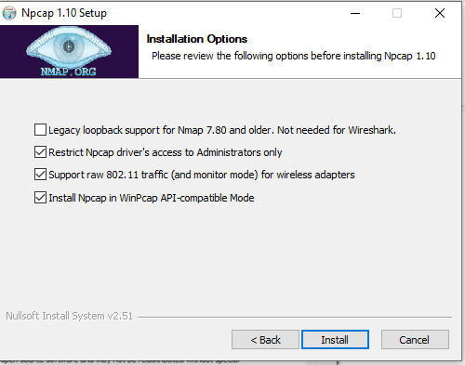

Figure 07: Choose Components to install for Npcap 1.10

12. Installation process starts and completes. Clicking on “Next” we have:

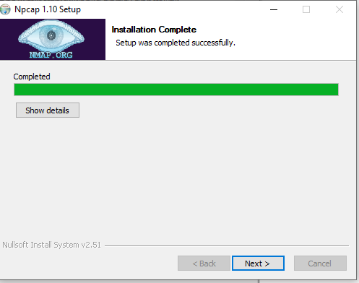

13. Now the window for installation of Npcap shows it has been installed. Clicking “Finish”.

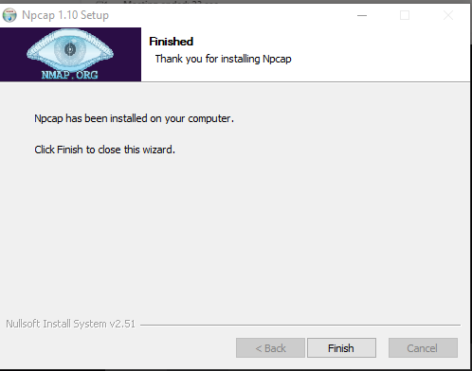

14. After installing Snort and Npcap enter these commands in windows 10 Command prompt to check snorts working

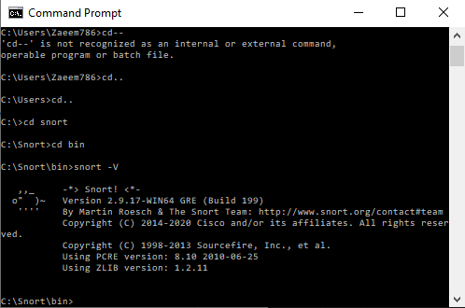

1. As you can see in the above figure that snort runs successfully.

This is how you can download and install Snort along with its dependency i.e. Npcap.

*Note: The italicized portion with a left hand side Border States commands which were pre-written in the configuration file of Snort so we need to make changes according to the commands mentioned in the images, to be precise we need to enter configuration commands as shown in the images to configure snort.*

1. Go to this[link](https://www.snort.org/downloads/#rule-downloads) and download latest snort rule file.
2. Extract 3 folders from the downloaded snortrules-snapshot-29170.tar folder into the Snorts corresponding folders in C drive.

Folders to be extracted are: rules , preproc_rules , etc

* Rules folder contains the rules files and the most important local. Rules file. Which we will use to enter all our rules.
* etc folder contains all configuration files and the most important file is snort.conf file which we will use for configuration

3. Now open the snort.conf file through the notepad++ editor or any other text editor to edit configurations of snort to make it work like we want it to.

4. Setup the network addresses you are protecting

ipvar HOME_NET any

Note: Mention your own host IP addresses that you want to protect.



Figure 11: Setting up the Home Network Address in Snort

5. Setup the external network into anything that is not the home network. That is why ! is used in the command it denotes ‘not’.

Set up the external network addresses. Leave as “any” in most situationsipvar EXTERNAL_NET any



Figure 12: Setting up the external Network Addresses in Snort

6. Now we have to define the directory for our rules and preproc rules folder

# Path to your rules files (this can be a relative path)# Note for Windows users: You are advised to make this an absolute path,# such as: c:\snort\rulesvar RULE_PATH ../rulesvar SO_RULE_PATH ../so_rulesvar PREPROC_RULE_PATH ../preproc_rules



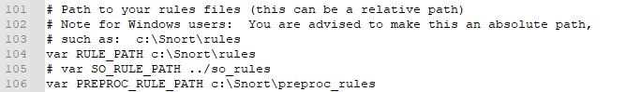

Figure 13: Setting up path to our rules files and preproc rules folder in Snort

7. Now we have to setup our white list and black list path it will be in our snorts’ rule folder

# If you are using reputation preprocessor set thesevar WHITE_LIST_PATH ../rulesvar BLACK_LIST_PATH ../rules





Figure 14: Setting up our White List and Black List files paths in Snort

8. Next we have to enable to log directory, so that we store logs in our log folder. Uncomment this line and set absolute path to log directory

# Configure default log directory for snort to log to. For more information see snort -h command line options (-l)## config logdir:





Figure 15: Setting up Log Directory Path in Snort

9. Now we will set the path to dynamic preprocessors and dynamic engine

# path to dynamic preprocessor libraries  
dynamic preprocessor directory/usr/local/lib/snort_dynamicpreprocessor/



Figure 16: Setting up path to dynamic preprocessors and dynamic engine in Snort

10. We will do same thing for dynamic preprocessor engine

# path to base preprocessor enginedynamicengine /usr/local/lib/snort_dynamicengine/libsf_engine.so



Figure 17: Setting up the path to dynamic preprocessor engine in Snort

11. Now lets set our reputation preprocessors:

# path to dynamic rules libraries# dynamicdetection directory /usr/local/lib/snort_dynamicrules



Figure 18: Path to dynamic rules libraries in Snort

12. Just comment out these lines as shown in figure 19 in doing so we are excluding packet normalization of different packets.

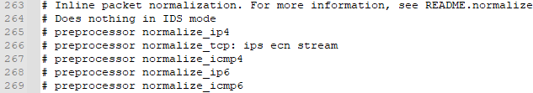

Figure 19: Commenting out packet normalization commands in Snort

13. Scroll down to the reputation preprocessors. We will just change the name of the files since white list , black list are not rules they are just the list of IP addresses labelled as black or white

# Reputation preprocessor. For more information see README.reputationpreprocessor reputation: \memcap 500, \priority whitelist, \nested_ip inner, \whitelist $WHITE_LIST_PATH/whitelist, \blacklist $BLACK_LIST_PATH\black.list



Figure 20: Whitelisting and Blacklisting IPs through the command as shown in figure

14. Converted back slashes to forward slashes in lines 546–651.

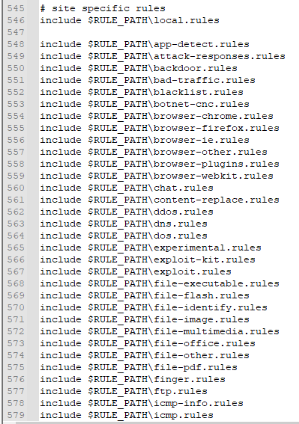

Figure 21 : Converted back slashes to forward slashes in specific lines in snort.conf file

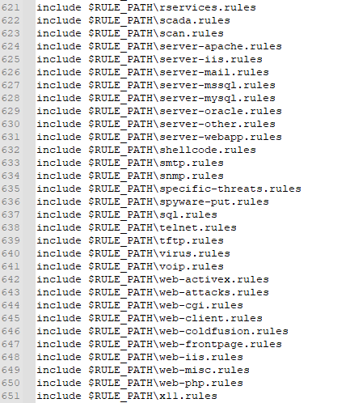

Figure 22: Converted back slashes to forward slashes in specific lines in snort.conf file

15. Again just convert forward slashes to backslashes and uncomment the lines below:

# decoder and preprocessor event rules# include $PREPROC_RULE_PATH/preprocessor.rules# include $PREPROC_RULE_PATH/decoder.rules# include $PREPROC_RULE_PATH/sensitive-data.rules

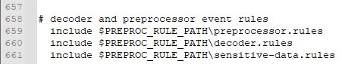

Figure 23 : Converted back slashes to forward slashes in specific lines and uncommenting specific lines in snort.conf file

16. Now we just need to verify the presence of this command at the bottom of snort.conf file.



Figure 24: verifying presence of “include threshold.conf” command in snort.conf file

17. Click on Save file and save all changes to save the configuration file (snort.conf).

18. Now recalling the Step 13 white list , black list are not rules they are just the list of IP addresses labelled as black or white right now these files don’t exist in our rule path which is why we have to create them manually , save them in this folder C:\Snort\rules.

* Go to Notepad++ and create new file.
* Comment it #White-listed IPs.
* Name the file white.list and save the file.

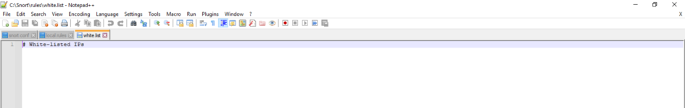

Figure 25 : Creating White List IPs file

* Create another new file.
* Comment it #Black-listed IPs.
* Name the file black.list and save the file.

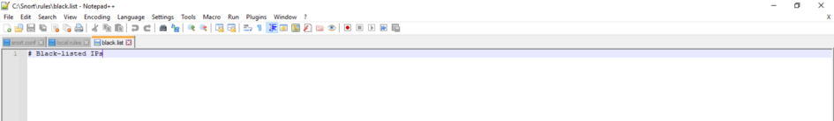

Figure 26 : Creating Black List IPs file in Snort

19. Now we test snort again by running Command prompt as admin. To check if it’s running fine after all the configurations.

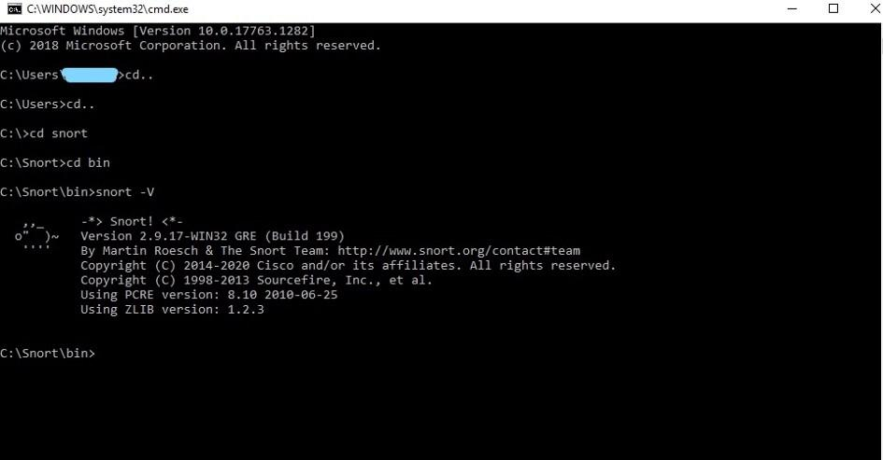

Figure 27: Test Running of Snort in Windows 10 after Configuration

20. We can also the check the wireless interface cards from which we will be using snort by using the command below we can see the list of our wireless interface cards through entering this command in command prompt.

Snort — W

21. configuration validation check command:  
Now we will enter a command To check validation of snort’s configuration  
by choosing a specific wireless interface card (1) the rest of command shows the config file path . The command is :

snort -i 1 -c C:\Snort\etc\snort.conf -T

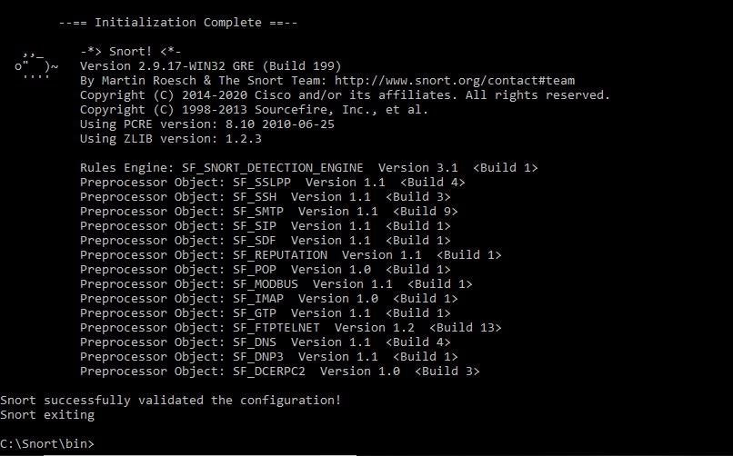

Figure 28 : Checking Validation of Snort Configuration in Command Prompt

**Result:**

Hence to study the Snort tool in different modes is done.

| **Ex. No :**  **Date:** | **Locate wireless networks using Netstumbler** |
| --- | --- |

**Aim:**

To locate wireless networks using Netstumbler.

**Description:**

 Network stumbler (NetStumbler) is a wireless LAN detection tool especially written for Windows operating system. It can detect IEEE 802.11b, 802.11g and 802.11a networks. (commonly known as WiFi) Netstumbler is a popular war driving tool. It also reveals some physical details like Signal, Noise, and SNR.

Downloading and installing of NetStumbler

Download the NetStumbler from the links given below

<https://www.netstumbler.com/downloads/>

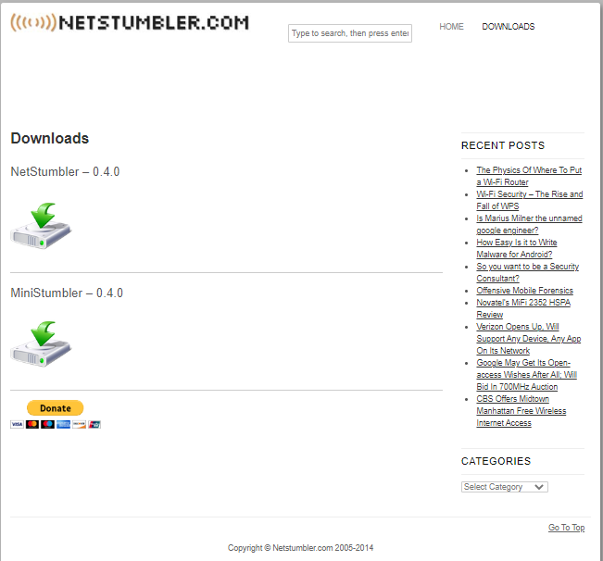

NetStumbler Scanning Environment

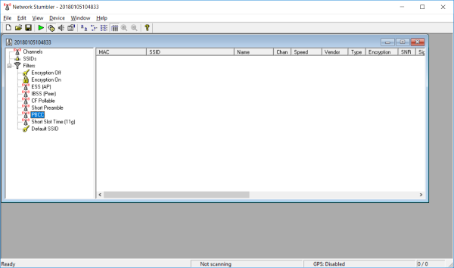

Steps for detecting wireless LAN networks with NetStumbler

**Step 1:** Set up the NetStumbler for Windows PC.

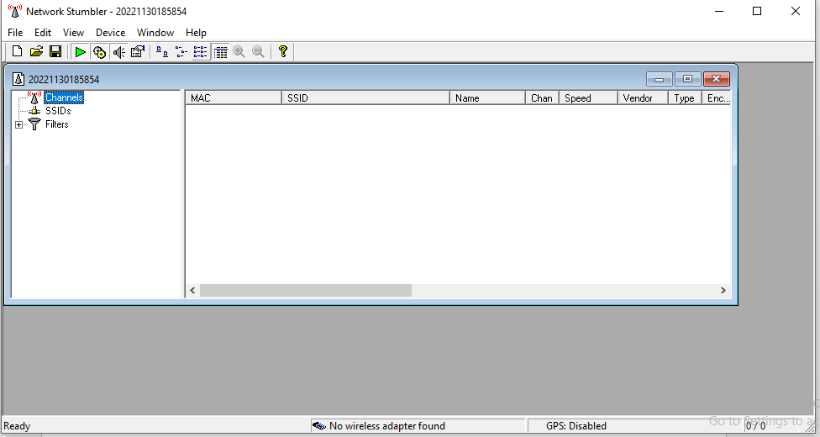

**Step 2**: select wireless adapter from the Devices menu

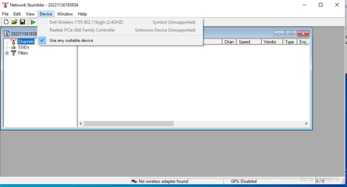

**Step 3**: then hit the green play button to start scanning.

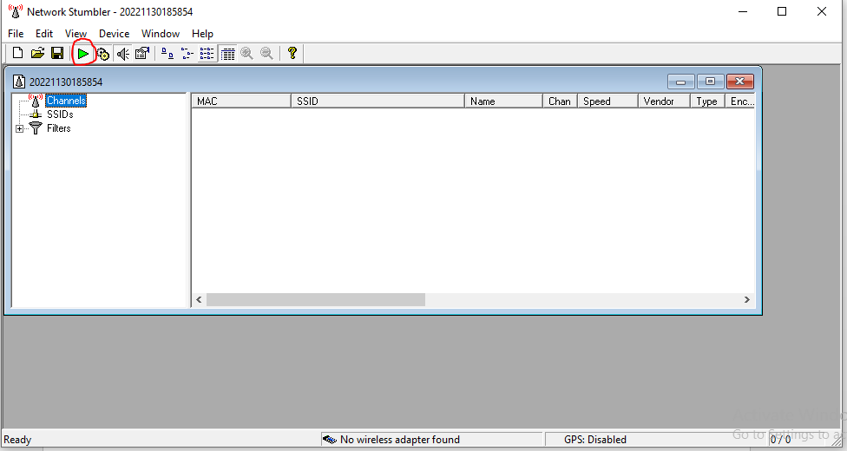

**Step 4**: Adjacent to the scan button, find the ‘Auto-Configure’ button to enable this to automatically configure network card for scanning.

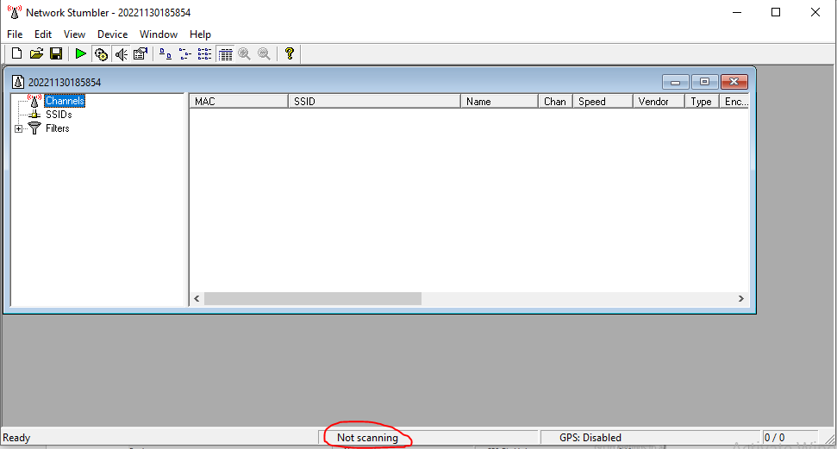

**Result:**

Thus the wireless networks have been located using Netstumbler.

| **Ex. No :**  **Date:** | **Identify password from pcap file captured from Wireshark** |
| --- | --- |

**Aim:**

To identify password from wireshark.

**Procedure:**

## Starting a Packet Capture

Click Start, Wireshark.

In Wireshark, on the left side, click "Interface List".

In the "Wireshark: Capture Interfaces" box, check all the interfaces, as shown below.

Click the Start button.

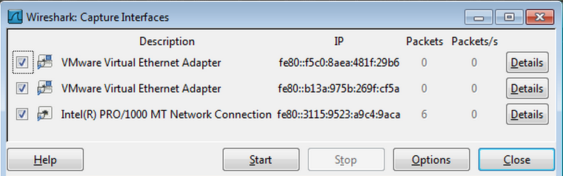

You should see packets being captured and scrolling by, as shown below on this page. Every packet sent from or to your machine is shown here. But it shows a lot more information than you usually want to know.

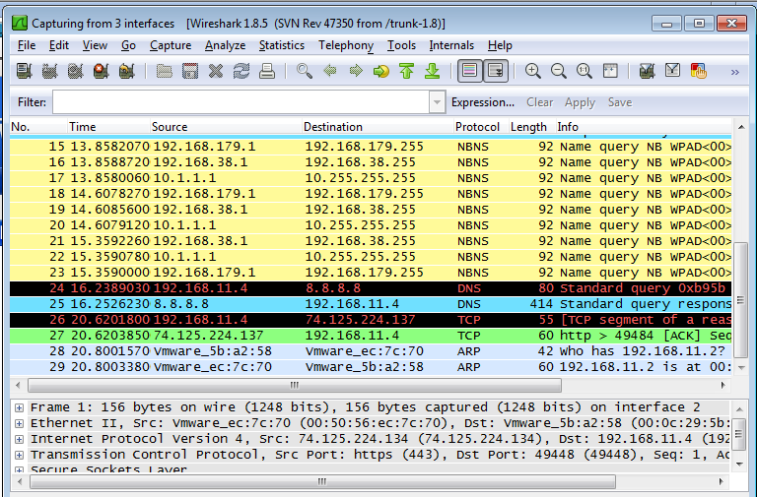

## Sending a Test Password to gogoNET

Open a Web browser and go to [gogo6.com](http://www.gogo6.com/)

On the top right of the screen, click "Sign In".

Enter a Username of YOURNAME@ccsf.edu (using your own name, not the literal string "YOURNAME") and a Password of topsecretpassword, as shown below:

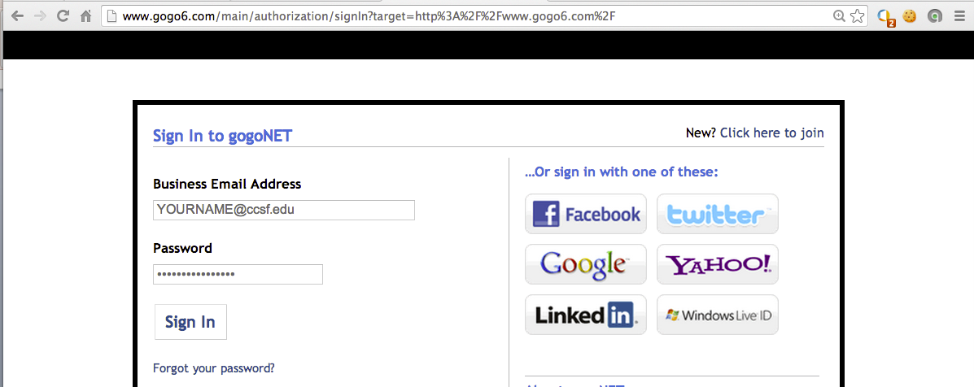

Click the "Sign In" button. If you see a message asking whether to remember the password, click "Not Now".

You see an error message from gogoNET saying the login failed.

That doesn't matter--the point of this project is to see how the password was sent to gogoNET.

In the Wireshark window, box, click Capture, Stop.

## Observing the Password in Wireshark

In the Wireshark window, box, in the Filter bar,type this filter, as shown below:

frame contains ccsf.edu

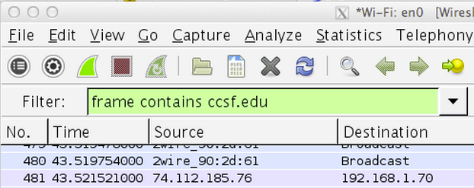

Wireshark shows an HTTP packet containing the text. In the upper pane of Wireshark, right-click the HTTP packet and click "Follow TCP Stream", as shown below.

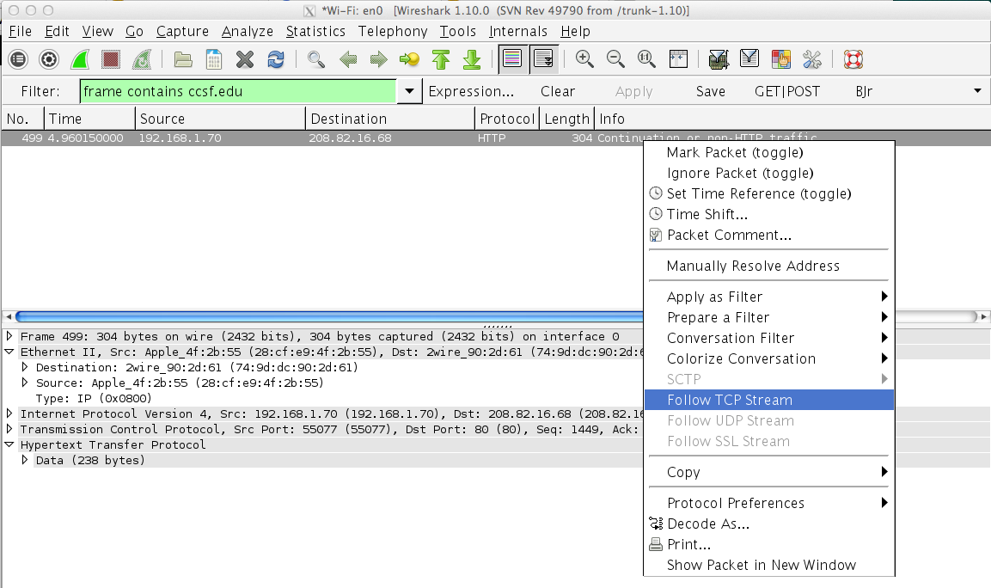

Expand the "Follow TCP Stream" box so that you can see YOURNAME and the password of topsecretpassword, as shown below.

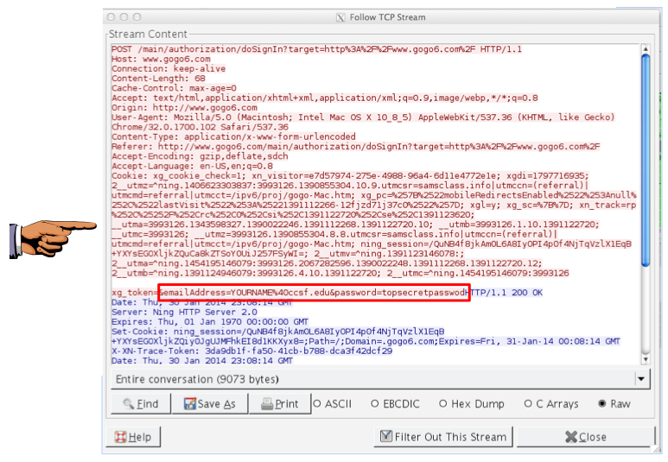

## Saving a Screen Image

Make sure your screen shows these required items in the captured packet:

* Your Name
* The captured password "topsecretpassword"

Press Ctrl+Alt to release the mouse from the Virtual Machine.

Press the PrintScrn key in the upper-right portion of the keyboard. That will copy the whole desktop to the clipboard.

YOU MUST SUBMIT AN IMAGE OF THE WHOLE DESKTOP TO GET FULL CREDIT!

Open Paint and paste in the image.

Save the image with the filename "Your Name Proj 3". Use your real name, not the literal text "Your Name".

## Starting another Packet Capture

From the Wireshark menu bar, click Capture, Start. A bob pops up asking "Do you want to save the captured packets before starting a new capture?" Click "Continue without saving".

## Using a Secure Password Transmission

In a Web browser, go to [http://gmail.com](https://gmail.com/)

Enter a Username of YOURNAME (using your own name, not the literal string "YOURNAME", and a Password of topsecretpassword, as shown below.

Click the "Sign in" button.

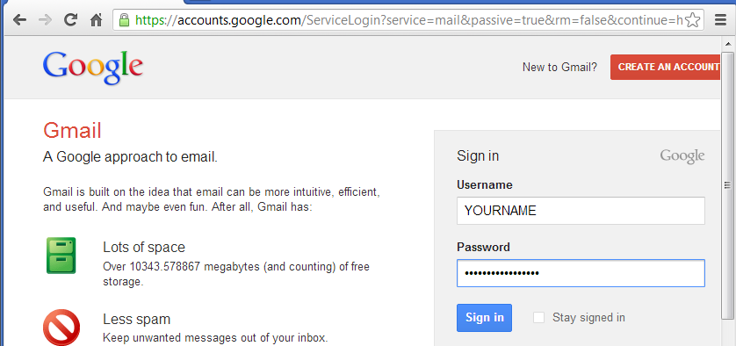

Gmail will reject the credentials, just like gogoNET did.

In the Wireshark window, box, click Capture, Stop.

## Searching for the Password in Wireshark

In the Wireshark window, box, click Edit, "Find Packet".

In the "Wireshark: Find Packet" box, click the String button. Enter a search string of secret, as shown below.

In the "Search In" section, click "Packet bytes".

Click Find.

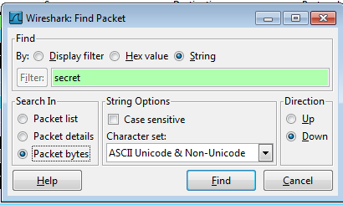

A message appears briefly in the status bar at the bottom of the Wireshark window, saying "No packet contained that string", as shown below.

The password cannot be found because Gmail encrypts it before transmitting it.

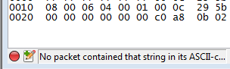

## Turning in your Project

Email the image to me as an email attachment. Send it to: cnit.120@gmail.com with a subject line of "Proj 3 From Your Name", replacing Your Name with your own first and last name. Send a Cc to yourself.

Last Modified: 1-30-14 3:14 pm

## Step 3: Getting to It

Now it has come to the point where I tell you how to get any password you could ever want, however its a little more tricky than that. Thank goodness some bright people have already thought this one through and made it nearly impossible to take just any password you want. The only passwords that you can see are ones that are not HTTPS packets. These HTTPS packets make up the majority of the packets that contain login information. However if you can manage to find a website that has little to no visitors I will now teach you how to locate the HTTP (Hyper Text Transfer Protocol) file that contains login information.

**Result:**

Hence to identify password from wireshark is done.

| **Ex. No :**  **Date:** | **Identify the parameters to secure WiFi network** |
| --- | --- |

**Aim:**

To identify the parameters to secure WiFi network.

**Procedure:**

Steps to identify the parameters to secure WiFi network

### Step 1. Open router settings

* First, need to know how to access wireless router’s settings and type: “192.168.1.1” into web browser, and then enter the correct user name and password for the router. This is different for each router, so first check router’s user manual.

Step 2. Create a unique password on router

* Once logged into router, first secure network is to change the default password* of the router to something more secure.
* This will prevent others from accessing the router and can easily maintain the security settings. Then change the password from the Administration settings on router’s settings page. The default values are generally admin / password.

### Step 3. Change Network’s SSID name

* The SSID (or Wireless Network Name) of Wireless Router is usually pre-defined as “default” or is set as the brand name of the router (e.g., linksys). Although this will not make network inherently* more secure, changing the SSID name of network is a good idea as it will make it more obvious for others to know which network they are connecting to.
* This setting is usually under the basic wireless settings in router’s settings page. Once this is set, will always be sure that are connecting to the correct Wireless network even if there are multiple wireless networks in area. Don’t use name, home address or other personal information in the SSID name.

### Step 4. Enable Network Encryption

* In order to prevent other computers in the area from using internet connection, need to encrypt wireless signals.
* There are several encryption methods for wireless settings, including [WEP](http://en.wikipedia.org/wiki/Wired_Equivalent_Privacy), [WPA](http://en.wikipedia.org/wiki/Wi-Fi_Protected_Access) (WPA-Personal), and [WPA2](http://en.wikipedia.org/wiki/IEEE_802.11i-2004) (Wi-Fi Protected Access version 2). WEP is basic encryption and therefore least secure (i.e., it can be easily cracked*, but is compatible with a wide range of devices including older hardware, whereas WPA2 is the most secure but is only compatible with hardware manufactured [since 2006](http://www.wi-fi.org/pressroom_overview.php?newsid=16).
* To enable encryption on Wireless network, open the wireless security settings on router’s configuration page. This will usually let select which security method wish to choose; if the older devices, choose WEP, otherwise go with WPA2. Enter a passphrase to access the network; make sure to set this to something that would be difficult for others to guess, and consider using a combination of letters, numbers, and special characters in the passphrase.

### Step 5. Filter MAC addresses

* Whether have a laptop or a Wi-Fi enabled mobile phone, all wireless devices have a unique [MAC address](http://en.wikipedia.org/wiki/Mac_address) (this has nothing to do with an Apple Mac) just like every computer connected to the Internet has a unique IP address. For an added layer of protection, can add the MAC addresses of all devices to wireless router’s settings so that only the specified devices can connect to Wi-Fi network.
* MAC addresses are hard-coded into networking equipment, so one address will only let that one device on the network. It is, unfortunately, possible to spoof a MAC address*, but an attacker must first know one of the MAC addresses of the computers that are connected to Wireless network before he can attempt spoofing.
* To enable MAC address filtering, first make a list of all hardware devices that want to connect to wireless network**. Find their MAC addresses, and then add them to the MAC address filtering in router’s administrative settings. Find the MAC address for computers by opening Command Prompt and typing in “ipconfig /all”, which will show MAC address beside the name “Physical Address”. Find the MAC addresses of Wireless mobile phones and other portable devices under their network settings, though this will vary for each device.

### Step 6. Reduce the Range of the Wireless Signal

* If wireless router has a high range but are staying in a small studio apartment, can consider decreasing the signal range by either changing the mode of router to 802.11g (instead of 802.11n or 802.11b) or use a different wireless channel.
* Also try placing the router under the bed, inside a shoe box or [wrap a foil](https://www.labnol.org/software/increase-wifi-signal-strength-with-aluminum/8064/) around the router antennas so that can somewhat restrict the direction of signals.
* Apply the Anti-Wi-Fi Paint - Researchers [have developed](http://news.bbc.co.uk/2/hi/technology/8279549.stm) a special Wi-Fi blocking paint that can help stop neighbors from accessing home network without having to set up encryption at the router level. The paint contains chemicals that blocks radio signals by absorbing them. “By coating an entire room, Wi-Fi signals can’t get in and, crucially, can’t get out.”

### Step 7. Upgrade Router’s firmware

* Check the manufacturer’s site occasionally to make sure that router is running the latest firmware. Find the existing firmware version of router using from the router’s dashboard at 192.168.*.

### Connect to Secure Wireless Network

* To conclude, MAC Address filtering with WPA2 (AES) encryption (and a really complex passphrase) is probably the best way to secure wireless network.
* After enabled the various security settings in wireless router, need to add the new settings to computers and other wireless devices so that they all can connect to the Wi-Fi network. Select to have computer automatically connect to this network, so won’t have to enter the SSID, passphrase and   other information every time connect to the Internet.

**Result:**

Thus the parameters have been identified to secure WiFi network.